
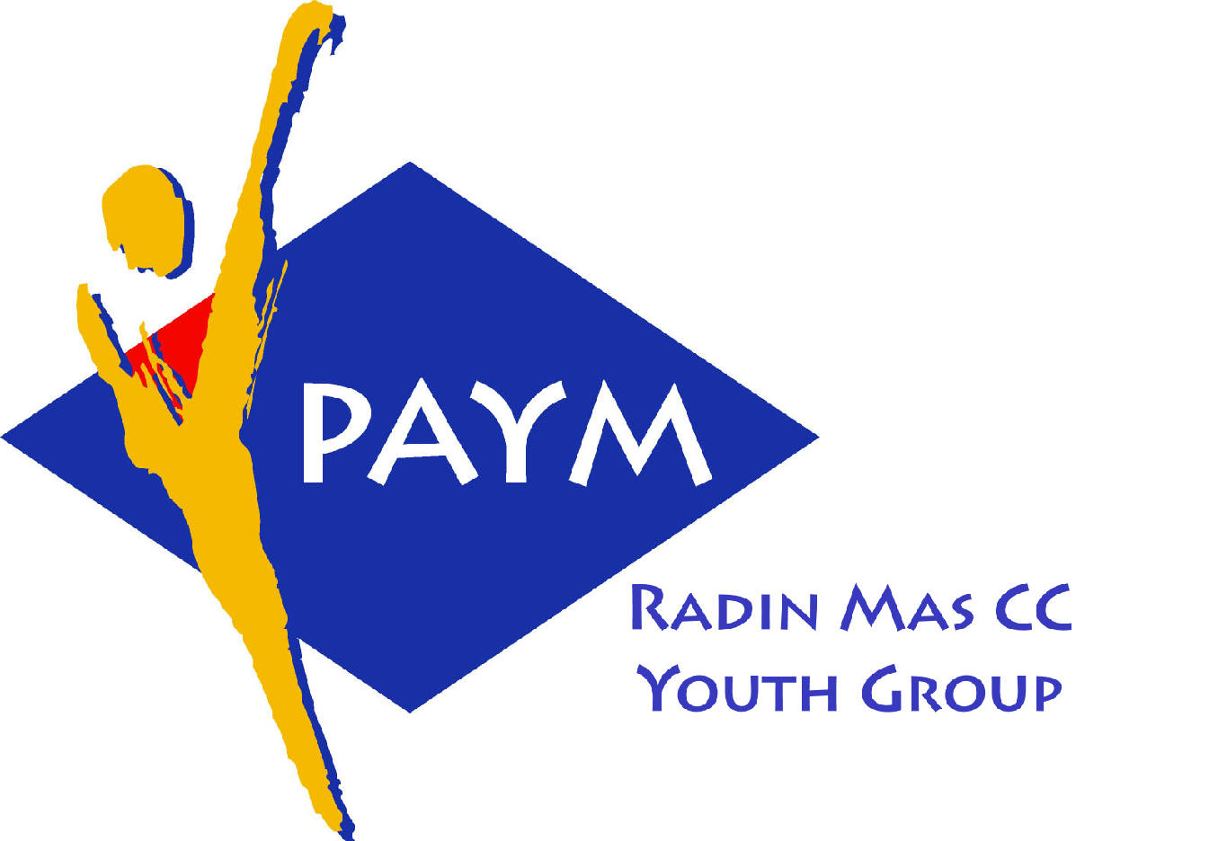
Radin Mas Toastmasters Club

District. 80 Division. D Area. D1 Club No.. 4436
An Activity Group of Radin Mas YEC
1, Telok Blangah Crescent, Singapore 098915
Tel. (65) 6273 5294 Fax. (65) 62730768
http.//www.geocities.com/rm_tmc

Club’s Mission: To provide a mutually supportive and positive learning environment in which every member has the opportunity to develop and practice communication and leadership skills which in turn will foster self-confidence and personal growth.
____________________________________________________________________________________________________________
77th Monthly Meeting of Radin Mas Toastmasters Club (2006/2007)
25th September 2006, Monday, 7.00 pm

Radin Mas Community Club, Level 2, Conference Room

7th Exco Committee  President  Eric Lau CTM CL  98500912 kedahans@hotmail.com  Vice President Education  Kelvin Wong CTM CL 98638603  khemery@starhub.net.sg  Vice President Membership  Jenny Lim 687022301/62764303  jkblim@yahoo.com.sg  Vice President Publicity  Ng Wei Lin 90094334  nwleli@singnet.com.sg  Secretary  Xing Ya Feng 94768136  YaFeng.Xing@mt.com  Treasurer  Deek Ann Lee 96851352  anndelle.lee@gmail.com  Sergeant-At-Arms  Tay Wee Leong 94305608  tayweeleong@hotmail.com  Immediate Past President  Thomas Lai Yew Fai CTM 96800177 laiyf@yahoo.com  Area D1 Governor  Rose Ho CL  Other Members  Chee Kim Loon ATMB CL  Helen Ang  Soh Lay Bing  Margaret Lau Kim Hong  Kathy Lam  Russell Cheong  Our next meeting is on  23 Oct 2006  Our next theme of the month  Fairy Tale  We meet on every 4th Monday of the month.  CTM: Competent Toastmaster  ATM: Advanced Toastmaster  (G: Gold S: Silver, B: Bronze)  DTM:Distinguished Toastmaster  CL: Competent Leader  AL Advanced Leader | 07:00 pm | Set up meeting venue | SAA & All Members
 | 07:15 pm | Fellowship | All Members
 | 07:30 pm (15mins) | SAA Warm Up Session & Introduction | Tay Wee Leong
 |  | Toastmaster of the Evening | Rose Ho CL
 |  | President’s Speech | Eric Lau CTM CL
 |  | Word of the Day (3mins) | Ong Sin Tiong ATMB AL
 | 07:45 pm (20 mins) | Table Topics | Charanjit Sidhu
 |  | Timer’s report | Thomas Lai CTM
 |  | Vote for The Best Table Topics Speaker | Tay Wee Leong
 | 08:15 pm (45 mins) | Prepared Speech | Rose Ho CL
 |  | CP4 How to say it (5 – 7 mins) | Soh Lay Bing
 |  | AP2 Speaking to Inform (5-7 mins) | Eric Lau CTM
 |  | AP2 The Successful Negotiator (10-14 mins) | Kelvin Wong CTM
 |  | CL Building a Team (10-14 mins) | Ann Lee CTM
 |  | Timer's Report | Thomas Lai CTM
 |  | Vote for The Best Speaker | Tay Wee Leong
 | 09:00 pm (15 mins) | Tea Break
 | 09:15 pm | SAA Call Meeting Into Session | Tay Wee Leong
 |  | Evaluation (2-3 mins) | Rose Ho CL
 |  | Evaluation for CP5 Your Body Speaks | Chee Kim Loon ATMB CL
 |  | Evaluation for AP2 Eric Lau CTM CL | Albert Lim DTM
 |  | Evaluation for AP2 Kelvin Wong CTM CL | Lim Poh Pian ATMB CL
 |  | Timer’s Report | Thomas Lai CTM
 |  | Vote for The Best Evaluator | Tay Wee Leong
 |  | Ah Counter Report | Jenny Lim
 | 09:30 pm | Language Evaluation (10 mins) | Ong Sin Tiong ATMB AL
 | 09:40 pm | Presenting of Awards and Closing Address | Eric Lau CTM CL
 | 09:50 pm | Home Sweet Home
Guests
Ong Sin Tiong ATMB AL, Division D Governor
Lim Poh Pian ATMB CL, Toa Payoh Toastmasters
Albert Lim DTM, Toa Payoh Toastmasters
Charanjit Sidhu, Toa Payoh Toastmasters
Upcoming Events
10 Oct, 17 Oct, 23 Oct, 31 Oct and Nov 7—Speechcraft 4th Intake
TI Night 20 Oct 2006
Congratulations to those who did well in Club Evaluation Contest in August:
Kelvin Wong CTM—Champion, (Runner-up in the Division Evaluation Contest)
Eric Lau CTM—Runner-up
Thomas Lai CTM—2nd runner-up

SPEECHCRAFT ADVISORS
We need volunteers for test speaker, timer, ah counter, etc, for all sessions. Sign your name below
Advisor (10 Oct) | Advisor (17 Oct) | Regular Meeting  (23 Oct) | Advisor (31 Oct) | Advisor (7 Nov)
TME—Charanjit Sidhu | TME—Charanjit Sidhu | TME—Charanjit Sidhu | TME—Charanjit Sidhu | TME—Charanjit Sidhu
Michael Rodrigues DTM | Maria Boey Yut Mei DTM | Lim Poh Pian ATMB CL | John Sih DTM —Poetry in Motion (1 hour) | Albert Lim DTM —Body Language talk and advisor
Ong Sin Tiong ATMB AL | Ong Sin Tiong ATMB AL | LE—Albert Lim DTM | Susan Wong DTM (Need reconfirmation) | Lim Poh Pian ATMB CL
Bruno Pereira ATMG CL | Bruno Pereira ATMG CL | Theresa Sng ATMB (Table Topic Master) | Eric Lau CTM CL | Edward Ma ATMB CL
Russell Cheong | Russell Cheong | Dr Khong DTM | Kevin Wong CTM | Evaluation by Yeo Chai Tun ATMS CL
Eric Lau CTM | Eric Lau CTM | Eric Lau CTM CL | Thomas Lai CTM | Rebecca Lee ATMB CL
Kevin Wong CTM | Kevin Wong CTM | Kevin Wong CTM CL |  | Eric Lau CTM CL
Thomas Lai CTM |  | Ann Lee CTM CL
P1 speaker | P2 speaker |  | P3 speaker | Evaluation Speaker
Attending as? | Attending as? |  | Attending as? | Attending as?

Speaking and Administrative Roles from Oct to Dec
Do put a tick in the slot below if you are able to hold any position or if you are giving a speech. Please pass the information to Kelvin for planning purposes

 | Oct 23 | Nov 27 | Dec 18
Attending? (Yes/No)
Speech title (if any)
Toastmaster of the Evening
Table Topic Master
Ah Counter
Timer
Evaluator

