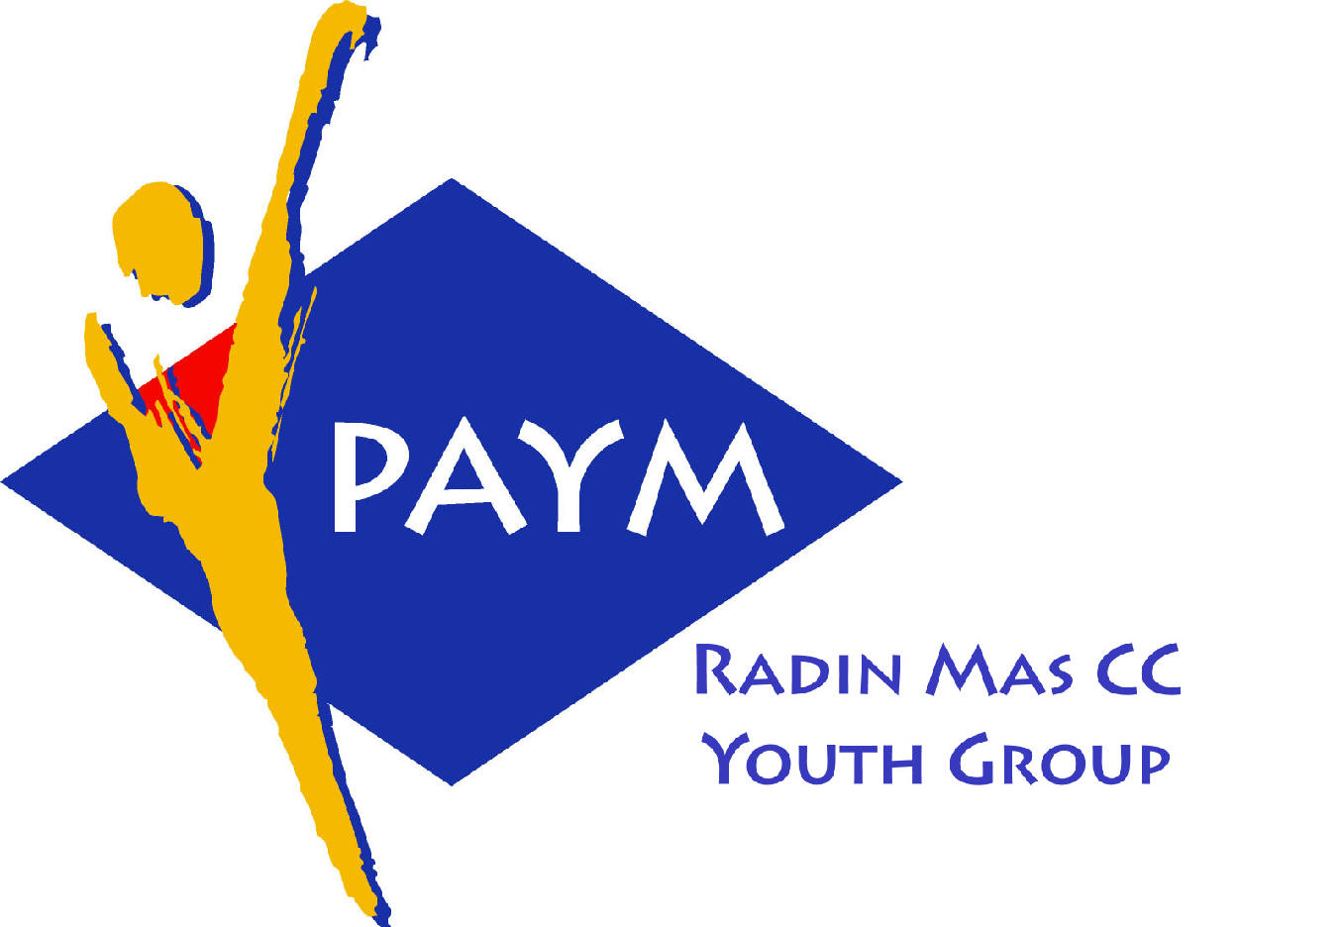
 Radin Mas Toastmasters Club

District. 80 Division. D Area. D1 Club No.. 4436
An Activity Group of Radin Mas YEC
1, Telok Blangah Crescent, Singapore 098915
Tel. (65) 6273 5294 Fax. (65) 62730768
http.//www.geocities.com/rm_tmc

Club Mission : To provide a mutually supportive and positive learning environment in which every member has the opportunity to develop communication and leadership skills, this in turn will foster self-confidence and personal growth.
_____________________________________________________________________________________________________
78th Monthly Meeting of Radin Mas Toastmasters Club (2006/2007)
23th October, Monday, 7.00 pm

Radin Mas Community Club, Level 2, Conference Room
7th Exco Committee  President  Eric Lau CTM CL  98500912 kedahans@hotmail.com  Vice President Education  Kelvin Wong CTM CL 98638603  khemery@starhub.net.sg  Vice President Membership  Jenny Lim 687022301/62764303  jkblim@yahoo.com.sg  Vice President Publicity  Russell Cheong 96910869  russellcheong@hotmail.com  Secretary  Xing Ya Feng 94768136  YaFeng.Xing@mt.com  Treasurer  Deek Ann Lee 96851352  anndelle.lee@gmail.com  Sergeant-At-Arms  Tay Wee Leong 94305608  tayweeleong@hotmail.com  Immediate Past President  Thomas Lai Yew Fai CTM 96800177 laiyf@yahoo.com  Area D1 Governor  Rose Ho CL  Other Members  Chee Kim Loon ATMB CL  Ng Wei Lin  Soh Lay Bing  Kathy Lam  Heng Siak Guan  Benson Tong Poon San  Chidambaram Saravanan  Chidambaram Thangaraju  Joseph Lim Kee Yong  Lim Mee Khim  Rama Devi Krishnan  Our next meeting is on  27 Nov 2006  Our next theme of the month  1960s  We meet on every 4th Monday of the month. | 7.00 pm | Reception and fellowship
 | 7.15 pm | SAA Warm Up Session | Tay Wee Leong
 | 7.40 pm | Toastmaster of the Evening | Charanjit Singh CC
 | 7.45 pm | Word of the Day | A/P Khong Chooi Peng DTM
 | 7.50pm | Club President’s Opening Address | Eric Lau CL
 | 7.55pm | Table Topics | Theresa Sng ATMB CL
 | 8.20pm | Timer’s Report | Chee Kim Loon ATMB CL
 | 8.25pm | Vote for Best Speaker | Tay Wee Leong
 | 8.30pm | Prepared Speech session (40 min) | Charanjit Singh CTM
 |  | P6 Vocal Variety (5-7min) | Tay Wee Leong
 |  | AP3 Diffusing Verbal Criticism (10-14 min) | Kelvin Wong CL
 |  | AP1 A Radio Talk Show (8 min) | Ann Lee CTM CL
 |  | Timer’s Report | Chee Kim Loon ATMB CL
 | 9.15pm | Vote for Best Speaker | Tay Wee Leong
 | 9.20pm | Break
 |  | Evaluation ( 2-3 min each) | Charanjit Singh CC
 | 9.30 pm | Project of Tay Wee Leong | Rose Ho CL
 |  | Project for Kelvin Wong | Yeo Chai Tun ATMS CL
 |  | Project for Ann Lee | Wong Kok Wah CL
 |  | Timer’s Report | Chee Kim Loon ATMB CL
 |  | Vote for Best Evaluator | Tay Wee Leong
 | 9.40 pm | Language Evaluation | A/P Khong Chooi Peng DTM
 | 9.50 pm | Ah Counter | John Choi
 | 9.55 pm | Closing Award & Address | Eric Lau CL
 | 10.00 pm | Home Sweet Home
Guests
Associate Professor Khong Chooi Peng DTM, Immediate Past District 80 Governor
Theresa Sng ATMB CL, President of New Millennium TMC
Wong Kok Wah CL, VPE of Brilliant Advanced TMC
Yeo Chai Tun ATMS CL, Asst Division Governor (Education & Training)

Acronyms
CTM: Competent Toastmaster; CC: Competent Communicator (from July 2006 onwards)
ATM: Advanced Toastmaster
(G: Gold S: Silver B: Bronze)
DTM: Distinguished Toastmaster
CL: Competent Leader
AL Advanced Leader

