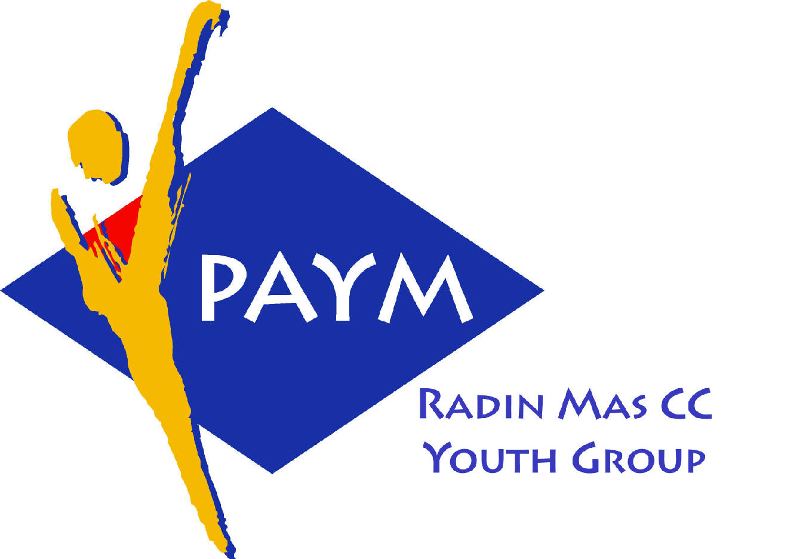
 Radin Mas Toastmasters Club

District. 80 Division. D Area. D1 Club No.. 4436
An Activity Group of Radin Mas YEC
1, Telok Blangah Crescent, Singapore 098915
Tel. (65) 6273 5294 Fax. (65) 62730768
http.//www.geocities.com/rm_tmc
Club Mission : To provide a mutually supportive and positive learning environment in which every member has the opportunity to develop communication and leadership skills, this in turn will foster self-confidence and personal growth.
_____________________________________________________________________________________________________
79th Monthly Meeting of Radin Mas Toastmasters Club (2006/2007)
27th Nov, Monday, 7.00 pm

Radin Mas Community Club, Level 2, Conference Room
7th Exco Committee  President  Eric Lau CTM CL 98500912 kedahans@hotmail.com  Vice President Education  Kelvin Wong CTM CL 98638603  khemery@starhub.net.sg  Vice President Membership  Jenny Lim 687022301/62764303  jkblim@yahoo.com.sg  Vice President Publicity  Russell Cheong 96910869  russellcheong@hotmail.com  Secretary  Xing Ya Feng 94768136  YaFeng.Xing@mt.com  Treasurer  Deek Ann Lee 96851352  anndelle.lee@gmail.com  Sergeant-At-Arms  Tay Wee Leong 94305608  tayweeleong@hotmail.com  Immediate Past President  Thomas Lai Yew Fai CTM 96800177 laiyf@yahoo.com  Area D1 Governor  Rose Ho CL  Other Members  Chee Kim Loon ATMB CL  Ng Wei Lin  Soh Lay Bing  Kathy Lam  Heng Siak Guan  Benson Tong Poon San  Chidambaram Saravanan  Chidambaram Thangaraju  Joseph Lim Kee Yong  Lim Mee Khim  Rama Devi Krishnan  Trixi Lim  Angie Leow  Jenny Low  Our next meeting is on  18 Dec 2006  We meet on every 4th Monday of the month. | 7.00 pm | Reception and fellowship
 | 7.15 pm | SAA Warm Up Session (Taboo) | Tay Wee Leong
 | 7.40 pm | Toastmaster of the Evening | Rose Ho CL
 | 7.45 pm | Word of the Day | Lim Seh Leng ATMB CL
 | 7.50 pm | Club President’s Opening Address | Eric Lau CL
 | 7.55 pm | Prepared Speech session (55 min)
 |  | P7 Apply Your Skills (5-7 min) | Tay Wee Leong
 |  | AP5 The Motivational Speech (15-20 min) | Charanjit Sidhu CC CL
 |  | AP2 Speaking to Inform (5-7 min) | Eric Lau CTM CL
 |  | AP4 The Coach (10-14 min) | Kelvin Wong CTM CL
 |  | AP3 The Persuasive Approach (8-10 min) | Ann Lee CC CL
 |  | Timer’s Report | Lim Mee Khim
 | 8.55 pm | Vote for the Best Speaker | Tay Wee Leong
 | 9.00 pm | Break (10min)
 | 9.10 pm | Evaluation ( 2-3 min each)
 |  | Evaluation for Tay Wee Leong | Thomas Lai CTM
 |  | Evaluation for Charanjit Sidhu | Chee Kim Loon ATMB CL
 |  | Evaluation for Eric Lau | John Choi CC
 |  | Evaluation for Kelvin Wong | William Lim DTM
 |  | Evaluation for Ann Lee | Theresa Sng ATMB CL
 |  | Timer’s Report | Lim Mee Khim
 |  | Vote for Best Evaluator | Tay Wee Leong
 | 9.25 pm | Language Evaluation | Lim Seh Leng ATMB CL
 | 9.40 pm | Ah Counter | Joseph Lim
 | 9.45pm | Induction Ceremony | Rose Ho CL
 | 9.55 pm | Closing Award & Address | Eric Lau CL
 | 10.00 pm | Home Sweet Home
Guests
Theresa Sng ATMB CL, President of New Millennium Advanced TMC
Lim Seh Leng ATMB CL, Vice-President Public Relations of Brilliant Advanced TMC
Charanjit Sidhu CC CL, Toa Payoh Central CC
William Lim DTM, President of West Coast TMC
Congratulations to those who did well in the last meeting:
Esther Lau—Best Table Topic Speaker
Kelvin Wong CTM CL—Best Prepared Speech
Acronyms
CTM: Competent Toastmaster; CC: Competent Communicator (from July 2006 onwards)
ATM: Advanced Toastmaster (G: Gold S: Silver B: Bronze)
DTM: Distinguished Toastmaster
CL: Competent Leader; AL: Advanced Leader

Toastmasters’ Pledge

We, the Toastmasters, pledge:
To support you in your quest for self development
To provide you with positive and helpful evaluations
To maintain a friendly and supportive atmosphere
To give you opportunities to help others
To make your TMs membership, a rewarding and fulfilling experience.

New Members Pledge

I, …………………………………….(Name of the New Member),

We will do our best…..
To attend meetings regularly and prepare fully for each assignment
To work faithfully on the projects outlined in the TMs’ manuals
To participate in Club activities
To evaluate others in a positive, constructive manner
To build open, friendly relationships with my fellow members
To bring other new members into the Club so that they can also benefit from the movement

Mentor | New Member
Tay Yiang Ping | Lim Mee Khim
Rose Ho | Joseph Lim
Chee Kim Loon | Heng Siak Guan
Thomas Lai | Rama Devi Krishnan
Eric Lau | Raju
Kelvin Wong | Angie Leow
Ann Lee | Jenny Low
Charanjit Sidhu | Saravanan
John Choi | Benson Tong

Other Club Meetings
1) Queenstown TMC
3rd and 5th Wednesday (Nov 29 and Dec 20)

President Eng Zee Lin 92383850

2) Toa Payoh Central Community Centre TMC
2nd Tue and 4th Thursday (Dec 12 and Dec 28)

President Suzanne Foo 96956050

3) Singapore Recreation Club (Opp. City Hall MRT)
2nd and 4th Wednesday (Dec 13 and Dec 27)

President Lilian Yap 96992260

4) New Millennium Advanced (Toa Payoh South CC)
Jan 20th 2-4.30pm Dr Khong on Conflict Resolution/4th Wed

President Theresa Sng 98587733

5) AIA Changi 160 Changi Road
2nd Thursday (Dec 14 / 6.30p.m.)

President James Keok 96313840

