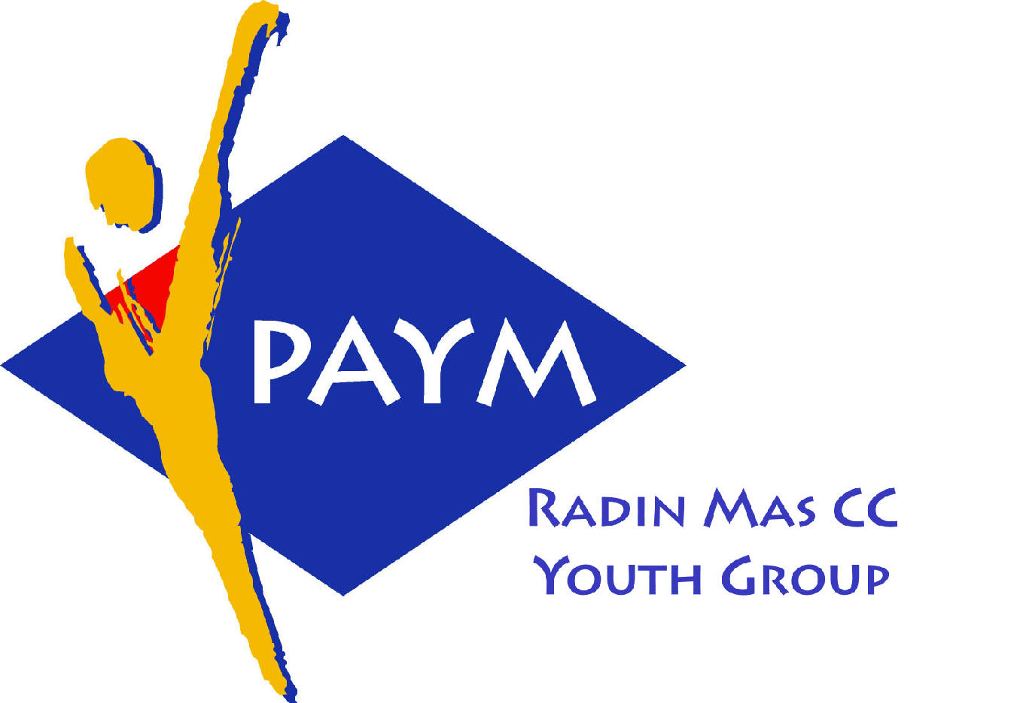
 Radin Mas Toastmasters Club

District. 80 Division. D Area. D1 Club No.. 4436
An Activity Group of Radin Mas YEC
1, Telok Blangah Crescent, Singapore 098915
Tel. (65) 6273 5294 Fax. (65) 62730768
http.//www.geocities.com/rm_tmc
Club Mission : To provide a mutually supportive environment in which every member has the opportunity to develop communication and leadership skills
_____________________________________________________________________________________________________
85th Monthly Meeting of Radin Mas Toastmasters Club (2006/2007)
May 28, Monday, 7.05 pm

Radin Mas Community Club, Level 2, Conference Room
7th Exco Committee  President  Eric Lau ACB CL 98500912 kedahans@hotmail.com  Vice President Education  Kelvin Wong CL 98638603  khemery@starhub.net.sg  John Choi CC 96986453  jluve@hotmail.com  Vice President Membership  Jenny Lim 687022301/62764303  jkblim@yahoo.com.sg  Vice President Public Relations  Russell Cheong 96910869  russellcheong@hotmail.com  Treasurer  Deek Ann Lee CC CL 96851352  anndelle.lee@gmail.com  Sergeant-At-Arms  Tay Wee Leong 94305608  tayweeleong@hotmail.com  Immediate Past President  Thomas Lai Yew Fai CTM  96800177 laiyf@yahoo.com  Area D1 Governor  Rose Ho CL  Other Members  Chee Kim Loon ATMB CL  Kathy Lam  Chidambaram Saravanan  Chidambaram Thangaraju  Peggy Pang  Ken Loh  Lou San Cheng  Trixi Lim  Angie Leow  Jenny Low  Moorthy Shanmugam  Our next meeting will be on  25 June 2007  We meet every 4th Monday | 7.05 pm | Reception and fellowship
 | 7.25 pm | SAA Warm Up Session | Tay Wee Leong
 | 7.35 pm | Toastmaster of the Evening | Thomas Lai CTM
 | 7.40 pm | President’s Opening Address ( AGM) | Eric Lau ACB CL
 | 7.55 pm | Prepared Speech Session (55 min)
 |  | P10 Inspire the audience (8-10 min) | Tay Wee Leong
 |  | P10 Inspire the audience (8-10 min) | Esther Leong
 |  | P10 Inspire the audience (8-10 min) | Russell Wong
 |  | AP4 Status Report (10-12 min) | Ann Lee CC CL
 |  | AP3 The Moral of the Story (4-6 min) | Kelvin Wong CL
 | 8.50 pm | Timer’s Report | Raju
 | 8.55 pm | Vote for the Best Speaker | Tay Wee Leong
 | 9.00 pm | Break (10min)
 | 9.10 pm | Evaluation (2-3 min each)
 |  | Evaluation for Tay Wee Leong
 |  | Evaluation for Esther Leong | Albert Lim DTM
 |  | Evaluation for Russell Wong | Eric Lau ACB CL
 |  | Evaluation for Ann Lee CC CL | Golam Hossain ACB CL
 |  | Evaluation for Kelvin Wong | Chee Kim Loon ATMB CL
 | 9.30 pm | Timer’s Report | Raju
 | 9.35 pm | Vote for Best Evaluator | Thomas Lai CTM
 | 9.40 pm | Language Evaluation | Albert Lim DTM
 | 9.50 pm | Ah Counter | Jenny Lim
 | 9.55 pm | Closing Award & Address | Eric Lau ACB CL
 | 10.00 pm | Home Sweet Home
Guests
Albert Lim DTM, District 80 Speechcraft Chair
Golam Hossain ACB CL, Division D Governor Elect
Congratulations to those who did well in the last meeting:
Best Speaker: Esther Leong
Best Table Topic Speaker: John Choi CC
Best Evaluator: Michael Wee DTM
Acronyms
CTM: Competent Toastmaster; ATM: Advanced Toastmaster (Before July 2006)
CC: Competent Communicator; AC: Advanced Communicator (from July 2006 onwards)
(G: Gold S: Silver B: Bronze)
DTM: Distinguished Toastmaster
CL: Competent Leader; AL: Advanced Leader

