
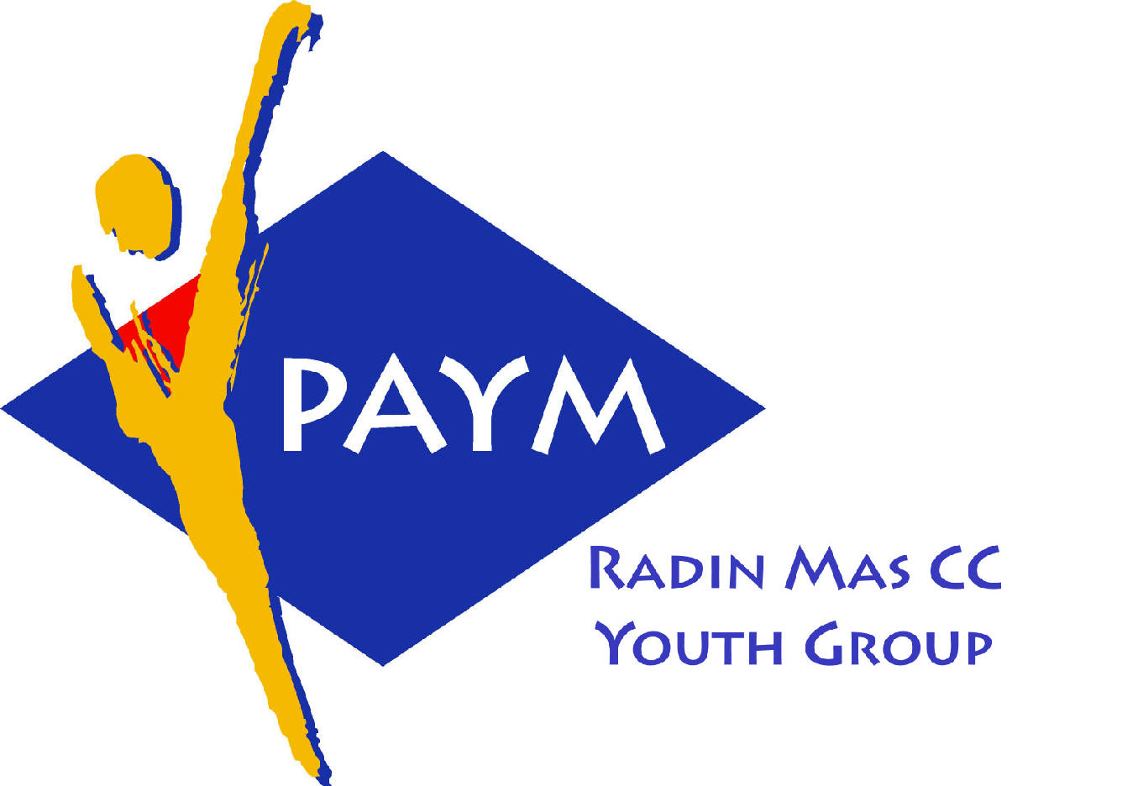
Radin Mas Toastmasters Club

District. 80 Division. D Area. D1 Club No.. 4436
An Activity Group of Radin Mas YEC
1, Telok Blangah Crescent, Singapore 098915
Tel. (65) 6273 5294 Fax. (65) 62730768
http.//www.geocities.com/rm_tmc

Club’s Mission: To provide a mutually supportive and positive learning environment in which every member has the opportunity to develop and practice communication and leadership skills which in turn will foster self-confidence and personal growth.
____________________________________________________________________________________________________________
75th Monthly Meeting of Radin Mas Toastmasters Club (2006/2007)
24th July 2006, Monday, 6.45 pm

Radin Mas Community Club, Level 2, Conference Room

7th Exco Committee  President  Eric Lau CTM, CL  98500912 kedahans@hotmail.com  Vice President Education  Kelvin Wong CTM, CL 98638603  khemery@starhub.net.sg  Vice President Membership  Jenny Lim 687022301/62764303  jkblim@yahoo.com.sg  Vice President Publicity  Ng Wei Lin 90094334  nwleli@singnet.com.sg  Secretary  Xing Ya Feng 94768136  YaFeng.Xing@mt.com  Treasurer  Deek Ann Lee 96851352  anndelle.lee@gmail.com  Sergeant-At-Arms  Tay Wee Leong 94305608  tayweeleong@hotmail.com  Immediate Past President  Thomas Lai Yew Fai CTM 96800177 laiyf@yahoo.com  Area D1 Governor  Rose Ho, CL  Other Members  Chee Kim Loon ATMB, CL  Helen Ang  Soh Lay Bing  Lau Kim Hong  Kathy Lam  Russell Cheong  Our next meeting is on  28 August 2006  (includes Evaluation Contest)  We meet on every 4th Monday of the month.  CTM: Competent Toastmaster  ATM: Advanced Toastmaster  (G: Gold S: Silver, B: Bronze)  DTM:Distinguished Toastmaster  CL: Competent Leader  AL Advanced Leader | 06:45 pm | Pot Luck Begins | SAA & All Members
 | 07:15 pm | SAA Warm Up Session & Introduction | Xing Ya Feng
 | 07:25 pm | Toastmaster of the Evening | Thomas Lai CTM
 | 07:30p.m. | Word of the Day (3mins) | Walter Tan CL
 | 07:35 pm | President’s Speech: Committed to a Hobby! | Eric Lau CTM, CL
 | 07:40 pm | Special Talk—“Goal” for It! | Tay Yiang Ping ATM-B, AL
 |  | Prepared Speech | Thomas Lai CTM
 | 07:55 pm | AP1 Public Relations ( 10 – 14 mins) | Ann Lee CTM
 |  | AP1 Conversing with Ease (10 – 14 mins) | Kelvin Wong CTM, CL
 |  | AP1 The Professional Speaker (10 – 20 mins) | D.D. Daruvala ATM-S, CL
 |  | AP1 Speaking to Inform (5-7mins) | Eric Lau CTM, CL
 |  | Timer’s report | Jenny Lim
 |  | Vote for The Best Speaker | Thomas Lai CTM
 | 09: 05 pm | Break (10 mins)
 | 09:15 pm | Evaluation (2-3 mins) | Thomas Lai CTM
 |  | Evaluation for AP1 Ann Lee CTM | Ong Sih Tiong ATM-B, AL
 |  | Evaluation for AP1 Kelvin Wong CTM, CL | David Chee, ATM-S, CL
 |  | Evaluation for AP1 D.D.Daruvala ATM-S, CL | David Goh, ATM-S, CL
 |  | Evaluation for AP1 Eric Lau CTM, CL | Devi Koperum ATM-S, CL
 |  | Timer’s Report | Jenny Lim
 |  | Vote for The Best Evaluator | Thomas Lai CTM
 |  | Ah Counter’s Report | Ng Wei Lin
 | 09:35 pm | Language Evaluation (10 mins) | Walter Tan CL
 | 09:45 pm | Presenting of Awards and Closing Address | Eric Lau CTM, CL
 | 09:50 pm | Home Sweet Home
Guests
Division D Governor, Ong Sih Tiong, ATM-B, AL
Area D1 Governor, Rose Ho, CL
Area D4 Governor, Devi Koperum, ATM-S, CL
D.D. Daruvala ATM-S, CL West Coast TMC Club Advisor
David Chee, ATM-S, CL, Toa Payoh Central TMC
David Goh, ATM-S, CL, Toa Payoh Central TMC, 2nd VPPR
Walter Tan, CL, Bukit Batok TMC
Congratulations to the following person who done well in the Last Meeting!
Kelvin Wong CTM, CL – Best Table Topics Speaker

Club Success Plan 1 July 2006 to 30th April 2007

 | Activity | Goal - by 30th Apr 2007 | Club’s Plan
1 | CC - Competent Communicator /CTM | - 2 | - The candidates are:  Ann Lee (Done!)  Xing Ya Feng
2 | Additional CCs/CTM | - 2 or more | - Other candidates to achieve CC during the term include:  Tay Wee Leong  Soh Lay Bing
3 | ACs (AC Bronze, AC Silver, AC Gold) | - 1 | - Most likely candidates are :  Kelvin Wong
4 | Additional ACs | - 1 or more | - Most likely candidates are:  Ann Lee
5 | CL, AL Bronze, AL Silver or DTM | - 1 | - The candidate is:  Kelvin Wong (Done!)
6 | Additional CL, AL Bronze, AL Silver or DTM | - 1 or more | - The candidate is:  Eric Lau (Done!)
7 | New members | - 4
8 | Additional new members | - 4 or more
9 | Club officer training | Minimum of four officers trained each of two training periods (Jul 06 and Jan 07) | 1st COT -15 July 2006 (Done!)  2nd COT – 13th Jan 2007
10 | Semiannual Membership Dues and Club Officer Lists | - Semiannual membership dues dates are 1st Oct 06 and 1st Apr 07  - Club officer list due date is June 30 2006

Note: In addition to the above, the Club must have minimum 20 members on June 2007 (or have a net growth of 5 new members during the term).
Achieve 5 of 10 goals - Distinguished Club
Achieve 7 of 10 goals - Select Distinguished Club
Achieve 9 of 10 goals - President’s Distinguished Club

If it falls your lot to be street-sweepers, sweep the streets like Michelangelo painted pictures, like Shakespeare wrote poetry, and like Beethoven composed music. Sweep the streets so well that all the hosts of heaven and earth would have to pause and say, “Here lived a great street sweeper, who swept his job well.”

Reverend Martin Luther King Jr.

