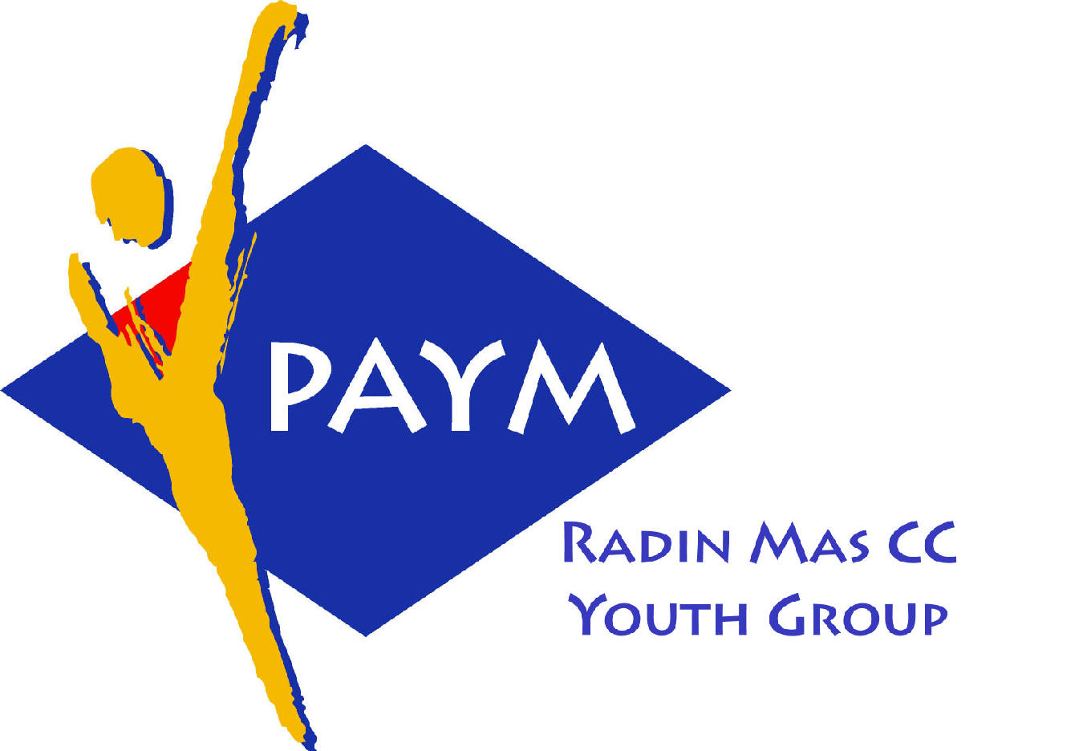
 Radin Mas Toastmasters Club

District. 80 Division. D Area. D1 Club No.. 4436
An Activity Group of Radin Mas YEC
1, Telok Blangah Crescent, Singapore 098915
Tel. (65) 6273 5294 Fax. (65) 62730768
http.//www.geocities.com/rm_tmc
Club Mission : To provide a mutually supportive and positive learning environment in which every member has the opportunity to develop communication and leadership skills, this in turn will foster self-confidence and personal growth.
_____________________________________________________________________________________________________
81st Monthly Meeting of Radin Mas Toastmasters Club (2006/2007)
22nd Dec, Monday, 7.00 pm

Radin Mas Community Club, Level 2, Conference Room
7th Exco Committee  President  Eric Lau CTM CL 98500912 kedahans@hotmail.com  Vice President Education  Kelvin Wong CTM CL 98638603  khemery@starhub.net.sg  Vice President Membership  Jenny Lim 1/62764303  jkblim@yahoo.com.sg  Vice President Publicity  Russell Cheong 96910869  russellcheong@hotmail.com  Secretary  Xing Ya Feng 94768136  YaFeng.Xing@mt.com  Treasurer  Deek Ann Lee 96851352  anndelle.lee@gmail.com  Sergeant-At-Arms  Tay Wee Leong 94305608  tayweeleong@hotmail.com  Immediate Past President  Thomas Lai Yew Fai CTM 96800177 laiyf@yahoo.com  Area D1 Governor  Rose Ho CL  Other Members  Chee Kim Loon ATMB CL  Ng Wei Lin  Soh Lay Bing  Kathy Lam  Heng Siak Guan  Benson Tong Poon San  Chidambaram Saravanan  Chidambaram Thangaraju  Joseph Lim Kee Yong  Lim Mee Khim  Rama Devi Krishnan  Trixi Lim  Angie Leow  Jenny Low  Our next meeting is on  26 Feb 2007  We meet every 4th Monday . | 7.00 pm | Reception and fellowship
 | 7.15 pm | SAA Warm Up Session | Tay Wee Leong
 | 7.35 pm | Toastmaster of the Evening | John Choi CC
 | 7.40 pm | Word of the Day | Poh Liang Siah CL
 | 7.45 pm | Table Topics | Rose Ho CL
 | 8.00 pm | Prepared Speech session (40 min)
 |  | P8 Get Comfortable with Visual Aids | Tay Wee Leong
 |  | P3 Organise Your Speech (5-7 min) | Trixi Lim
 |  | P4 Show What You Mean (5-7 min) | Jenny Low
 |  | P5 Your Body Speaks (5-7 min) | Raju
 |  | P5 Your Body Speaks (5-7 min) | Angie Leow
 |  | Timer’s Report | Ng Wei Lin
 | 8.40 pm | Vote for the Best Speaker | Tay Wee Leong
 | 8.45 pm | Break (15min)
 | 9.00 pm | Evaluation ( 2-3 min each)
 |  | Evaluation for Tay Wee Leong | Yap Boon Liang CL
 |  | Evaluation for Trixi Lim | Chee Kim Loon ATMB CL
 |  | Evaluation for Jenny Low | Eric Lau CTM CL
 |  | Evaluation for Raju | Thomas Lai CTM
 |  | Evaluation for Angie Leow | C P Lee CC CL
 |  | Timer’s Report | Ng Wei Lin
 |  | Vote for Best Evaluator | Tay Wee Leong
 | 9.20 pm | Language Evaluation | Poh Liang Siah CL
 | 9.30 pm | Ah Counter | Jenny Lim
 | 9.40 pm | Closing Award & Address | Eric Lau CTM CL
 | 9.50 pm | Home Sweet Home
Guests
Poh Liang Siah CL, Past President of Queenstown TMC
Yap Boon Liang CL, Asst Division Governor (Public Relations)
C P Lee CC CL, VPE of Nee Soon South TMC
Congratulations to those who did well in the last meeting:
Rose Ho CL—Best Table Topic Speech
Angie Leow—Best Prepared Speech
Acronyms
CTM: Competent Toastmaster; CC: Competent Communicator (from July 2006 onwards)
ATM: Advanced Toastmaster (G: Gold S: Silver B: Bronze)
DTM: Distinguished Toastmaster
CL: Competent Leader; AL: Advanced Leader

