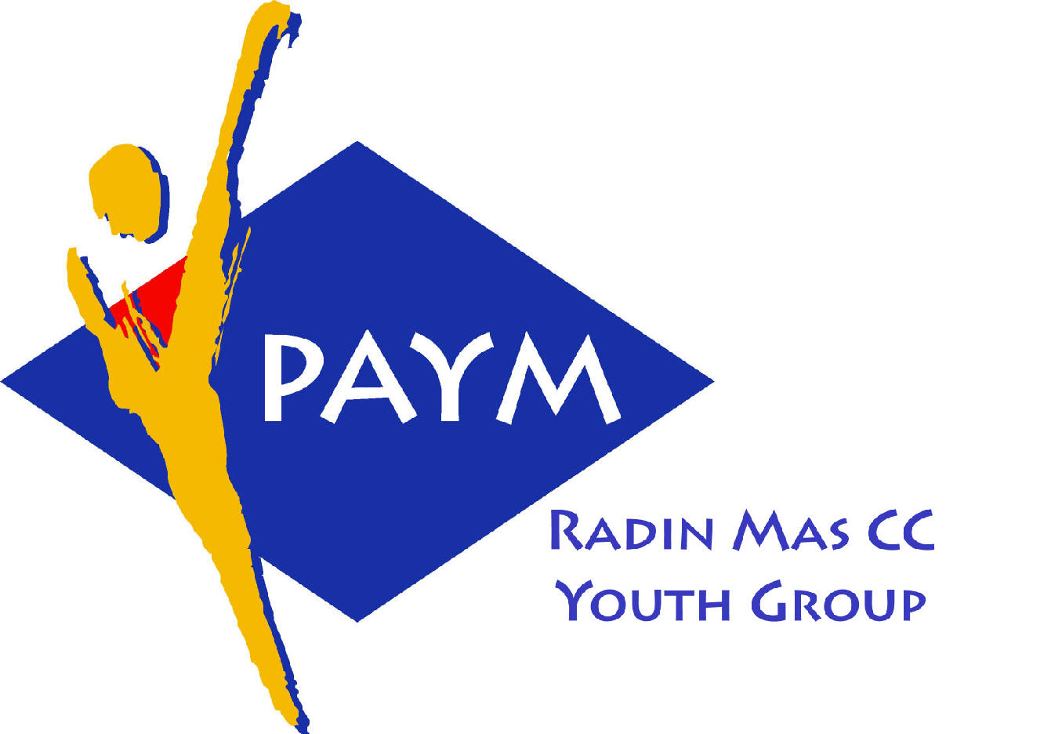
 Radin Mas Toastmasters Club

District. 80 Division. D Area. D1 Club No.. 4436
An Activity Group of Radin Mas YEC
1, Telok Blangah Crescent, Singapore 098915
Tel. (65) 6273 5294 Fax. (65) 62730768
http.//www.geocities.com/rm_tmc
Club Mission : To provide a mutually supportive and positive learning environment in which every member has the opportunity to develop communication and leadership skills, this in turn will foster self-confidence and personal growth.
_____________________________________________________________________________________________________
80th Monthly Meeting of Radin Mas Toastmasters Club (2006/2007)
18th Dec, Monday, 7.00 pm

Radin Mas Community Club, Level 2, Conference Room
7th Exco Committee  President  Eric Lau CTM CL 98500912 kedahans@hotmail.com  Vice President Education  Kelvin Wong CTM CL 98638603  khemery@starhub.net.sg  Vice President Membership  Jenny Lim 1/62764303  jkblim@yahoo.com.sg  Vice President Publicity  Russell Cheong 96910869  russellcheong@hotmail.com  Secretary  Xing Ya Feng 94768136  YaFeng.Xing@mt.com  Treasurer  Deek Ann Lee 96851352  anndelle.lee@gmail.com  Sergeant-At-Arms  Tay Wee Leong 94305608  tayweeleong@hotmail.com  Immediate Past President  Thomas Lai Yew Fai CTM 96800177 laiyf@yahoo.com  Area D1 Governor  Rose Ho CL  Other Members  Chee Kim Loon ATMB CL  Ng Wei Lin  Soh Lay Bing  Kathy Lam  Heng Siak Guan  Benson Tong Poon San  Chidambaram Saravanan  Chidambaram Thangaraju  Joseph Lim Kee Yong  Lim Mee Khim  Rama Devi Krishnan  Trixi Lim  Angie Leow  Jenny Low  Our next meeting is on  22 Jan 2007  We meet on every 4th Monday of the month. | 7.00 pm | Reception and fellowship
 | 7.15 pm | SAA Warm Up Session | Heng Siak Guan
 | 7.30 pm | Toastmaster of the Evening | Tay Wee Leong
 | 7.35 pm | Word of the Day | Albert Lim DTM
 | 7.40 pm | Table Topics | John Choi CC
 | 7.55 pm | Prepared Speech session (55 min)
 |  | P4 Show What You Mean (5-7 min) | Lim Mee Khim
 |  | P3 Organise Your Speech (5-7 min) | Jenny Low
 |  | P4 Show What You Mean (5-7 min) | Raju
 |  | P4 Show What You Mean (5-7 min) | Jenny Lim
 |  | AP5 Asserting Yourself Effectively (10-14 min) | Kelvin Wong CTM CL
 |  | P4 Show What You Mean (5-7 min) | Angie Leow
 |  | Timer’s Report | Shanmugam
 | 8.55 pm | Vote for the Best Speaker | Heng Siak Guan
 | 9.00 pm | Break (10min)
 | 9.10 pm | Evaluation ( 2-3 min each)
 |  | Evaluation for Lim Mee Khim | Rose Ho CL
 |  | Evaluation for Jenny Low | Thomas Lai CTM
 |  | Evaluation for Raju | Chee Kim Loon ATMB CL
 |  | Evaluation for Jenny Lim
 |  | Evaluation for Kelvin Wong | Lim Poh Pian ATMB CL
 |  | Evaluation for Angie Leow
 |  | Timer’s Report | Shanmugam
 |  | Vote for Best Evaluator | Heng Siak Guan
 | 9.25 pm | Language Evaluation | Albert Lim DTM
 | 9.40 pm | Ah Counter | Saravanan
 | 9.55 pm | Closing Award & Address | Kelvin Wong CTM CL
 | 10.00 pm | Home Sweet Home
Guests
Albert Lim DTM, District 80 Speechcraft Chair
Lim Poh Pian ATMB CL, Immediate Past President of Toa Payoh Central CC
Congratulations to those who did well in the last meeting:
Eric Lau—Best Prepared Speech
William Lim DTM—Best Evaluator
Acronyms
CTM: Competent Toastmaster; CC: Competent Communicator (from July 2006 onwards)
ATM: Advanced Toastmaster (G: Gold S: Silver B: Bronze)
DTM: Distinguished Toastmaster
CL: Competent Leader; AL: Advanced Leader

