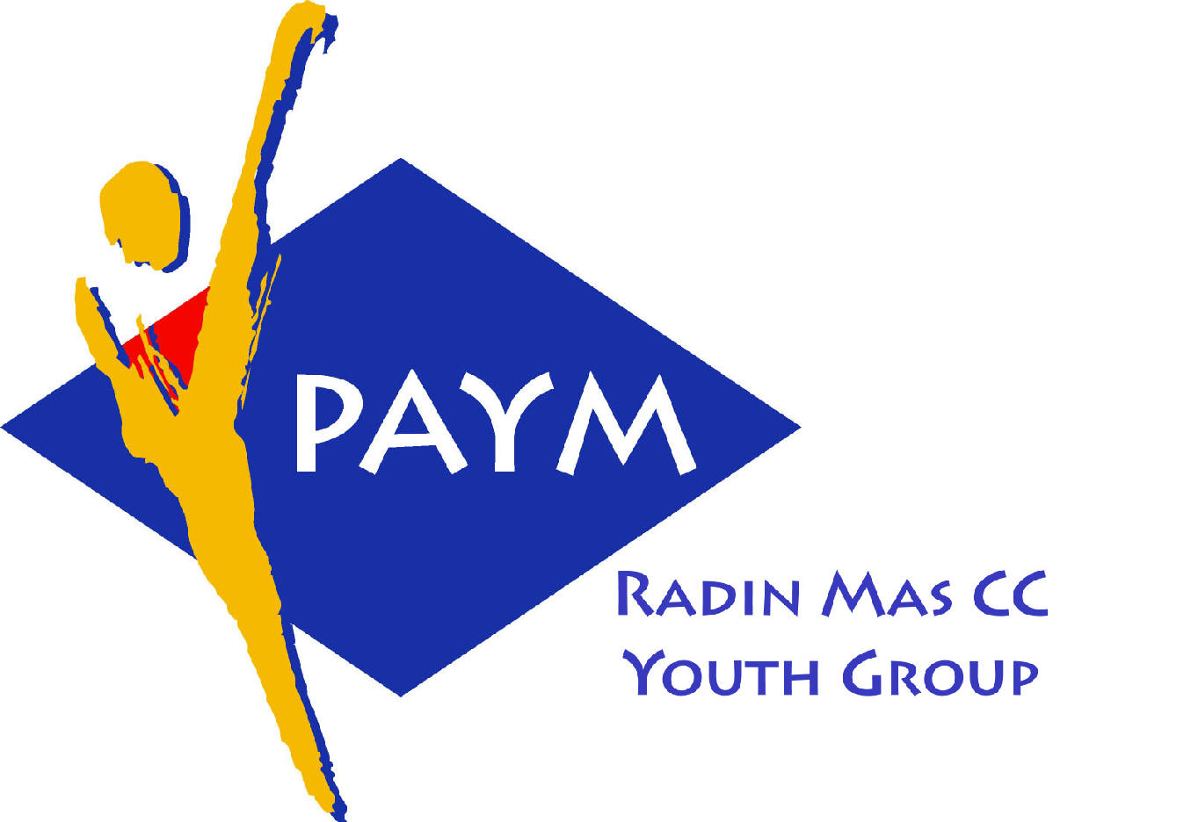
 Radin Mas Toastmasters Club

District: 80 Division: D Area: D1 Club No.: 4436
An Activity Group of Radin Mas YEC
1, Telok Blangah Crescent, Singapore 098915
Tel: (65) 6273 5294 Fax: (65) 62730768
http://www.geocities.com/rm_tmc
Club Mission: To provide a mutually supportive and positive learning environment in which every member has the opportunity to develop communication and leadership skills, this in turn will foster self-confidence and personal growth.
_____________________________________________________________________________________________________
53rd Monthly Meeting of Radin Mas Toastmasters Club (2004/2005)
27th September, Monday, 7.00 pm

Radin Mas Community Club, Level 2, Conference Room
5th Exco Committee  President  Vico Liew Yue Wah  97505876  mombasasm@yahoo.com.sg  Vice President Education  Thomas Lai Yew Fai  96800177  laiyf@yahoo.com  Vice President Membership  Tay Yiang Ping ATMB, CL  96221803  yptay@starhub.net.sg  Vice President Publicity  Gabriel Ho  91015751  Gabriel_hch@yahoo.com  Secretary  Chee Kim Loon, CTM  96980338  kimloon@singnet.com.sg  Treasurer  Roger Soh CL  98489205  rogersoh@starhub.net.sg  Sergeant-At-Arms  Russell Cheong  96910869  russellcheong@hotmail.com  Immediate Past President  Roger Soh CL  98489205  rogersoh@starhub.net.sg  Club Advisor:  Susan Wong DTM  Club Coaches:  David Chee, ATM-S, CL  Lynn Desker DTM  Area D1 Governor:  Chee Kim Loon, CTM  Our next meeting  on 25 October 2004 (Monday)  We meet every 4th Monday of the month. | 7.00 pm | Reception and fellowship
 | 7.20 pm | SAA Warm Up Session | Thomas Lai
 | 7.28 pm | Toastmaster of the Evening | Tay Yiang Ping ATMB CL
 | 7.30 pm | Word of the Day | Kris Tay ATMB CL
 | 7:35 pm | Club President Opening Address | Vico Liew
 | 7:38pm | Table Topics | Roger Soh CL
 |  | Prepared Speech session
 | 8.00 pm | P2: Speak With Sincerity (3-5 mins) | Chan Chee Phiew
 | 8.05pm | P2: Speak With Sincerity (3-5 mins) | Yvonne Chai
 | 8:10pm | P4: Show What You Mean (5-7 mins) | Russell Cheong
 | 8:18pm | P6: Work With Words (5-7 mins) | Thomas Lai
 | 8:26pm | Timer Report | Teo Yee Lee
 |  | Break
 |  | Evaluation ( 2-3 mins each)
 | 8:50pm | For Chan Chee Phiew | Tay Yiang Ping ATMB CL
 | 8:54pm | For Yvoone Chai | Vico Liew
 | 8:58pm | For Russell Cheng | Bruno Pereira ATMS CL
 | 9.02pm | For Thomas Lai | Chee Kim Loon CTM
 | 9:06pm | Timer Report | Teo Yee Lee
 | 9:07pm | Ah Counter Report | Lee Yee Ming
 | 9:09pm | Language Evaluation | Kris Tay ATMB CL
 | 9:20pm | General Evaluation | John Tan ATMG
 | 9.30pm | Closing Award & Address | Vico Liew
 | 9.35 pm | Home Sweet Home
External Guest:
Bruno Pereira ATMS, CL, Club President, Tampines Changkat, VPE, New Millennium Adv TMC
David Chee ATMS CL, IPP New Millennium Adv TMC,Division D Assist. Governor, Membership
Kris Tay ATMB CL, Club President, Sky Media TMC
John Tan, ATMG, IPP, Siglap TMC
Announcement:
Club President, Vico Lew, Champion of Evaluation Contest
and IPP, Roger Soh, 2nd Place of Humorous Speech Contest in Area D1
22nd September 2004 at Queenstown CC

Division D Humorous and Evaluation Speech Contest 16 Oct, Saturday
Speechcraft Session 3, 8 Oct, Monday
Speechcraft Session 4, 15 Oct, Monday

