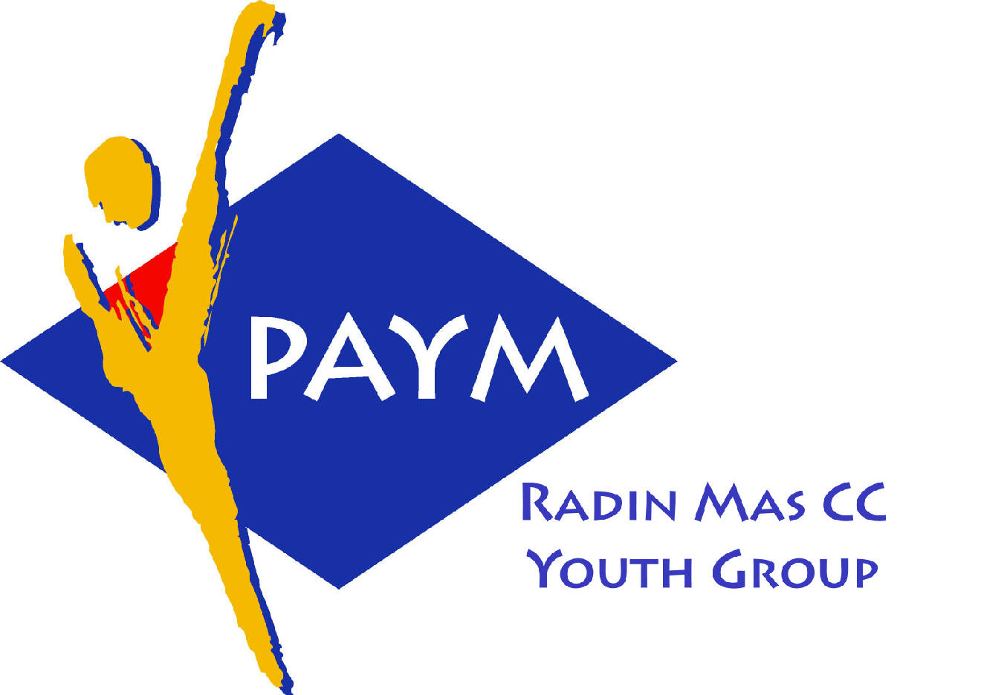
 Radin Mas Toastmasters Club

District: 80 Division: D Area: D1 Club No.: 4436
An Activity Group of Radin Mas YEC
1, Telok Blangah Crescent, Singapore 098915
Tel: (65) 6273 5294 Fax: (65) 62730768
http://www.geocities.com/rm_tmc
Club Mission: To provide a mutually supportive and positive learning
environment in which every member has the opportunity to develop communication and leadership skills, this in turn will foster self-confidence and personal growth.
_____________________________________________________________________________________________________
54th Monthly Meeting of Radin Mas Toastmasters Club (2004/2005)
25th October, Monday, 7.00 pm

Radin Mas Community Club, Level 2, Conference Room
5th Exco Committee  President  Vico Liew Yue Wah  97505876  mombasasm@yahoo.com.sg  Vice President Education  Thomas Lai Yew Fai  96800177  laiyf@yahoo.com  Vice President Membership  Tay Yiang Ping ATMB, CL  96221803  yptay@starhub.net.sg  Vice President Publicity  Gabriel Ho  91015751  Gabriel_hch@yahoo.com  Secretary  Chee Kim Loon, CTM  96980338  kimloon@singnet.com.sg  Treasurer  Roger Soh CL  98489205  rogersoh@starhub.net.sg  Sergeant-At-Arms  Russell Cheong  96910869  russellcheong@hotmail.com  Immediate Past President  Roger Soh CL  98489205  rogersoh@starhub.net.sg  Club Advisor:  Susan Wong DTM  Club Coaches:  David Chee, ATM-S, CL  Lynn Desker DTM  Area D1 Governor:  Chee Kim Loon, CTM  Our next meeting  on 22November (Monday)  We meet every 4th Monday of the month. | 7.00 pm | Reception and fellowship
 | 7.20 pm | SAA Warm Up Session | Margaret Lau
 | 7.28 pm | Toastmaster of the Evening | Chee Kim Loon CTM
 | 7.30 pm | Word of the Day | Richard Sng DTM
 | 7:35pm | Table Topics | Helen Ang
 |  | Timer’s Report | Margaret Lau
 |  | Prepared Speech session
 | 8:05 pm | P4: Show What You Mean (5-7 mins) | Eric Lau
 | 8:13pm | AP4: Specialty Speeches-Read Out Loud (12-15 mins) | Bruno Pereira ATMS CL
 | 8:29pm | Timer’s Report | Margaret Lau
 |  | Break
 |  | Evaluation ( 2-3 mins each)
 | 8:48pm | For Eric Lau | Philip Tan
 | 8:52pm | For Bruno Pereira | Clara Chang DTM
 | 9:00pm | Timer’s Report | Margaret Lau
 | 9:01pm | Ah Counter Report | Teo Yee Lee
 | 9:03pm | Language Evaluation | Richard Sng DTM
 | 9:13pm | General Evaluation | Teo Kim See ATMB CL
 | 9.23pm | Closing Award & Address | Thomas Lai
 | 9.30 pm | Home Sweet Home
External Guest:
Richard Sng DTM – Club President, Brilliant Adv TMC
Burno Pereira ATMS CL – Club President, Tampines Changkat TMC, VPE New Millennium
Teo Kim See ATMB CL - IPP Raffles Town TMC
Last Meeting:
Congratulations to Chan Chee Phiew awarded the Best Prepared Speech Speaker!
Congratulations to John Tan ATMG awarded the Best Table Topics Speaker!
Congratulations to Bruno Pereira ATMS CL awarded the Best Evaluator!
Announcement:
KL 2004, District 51 & 80 Semi-Annual Convention 26th – 28th Nov 2004

