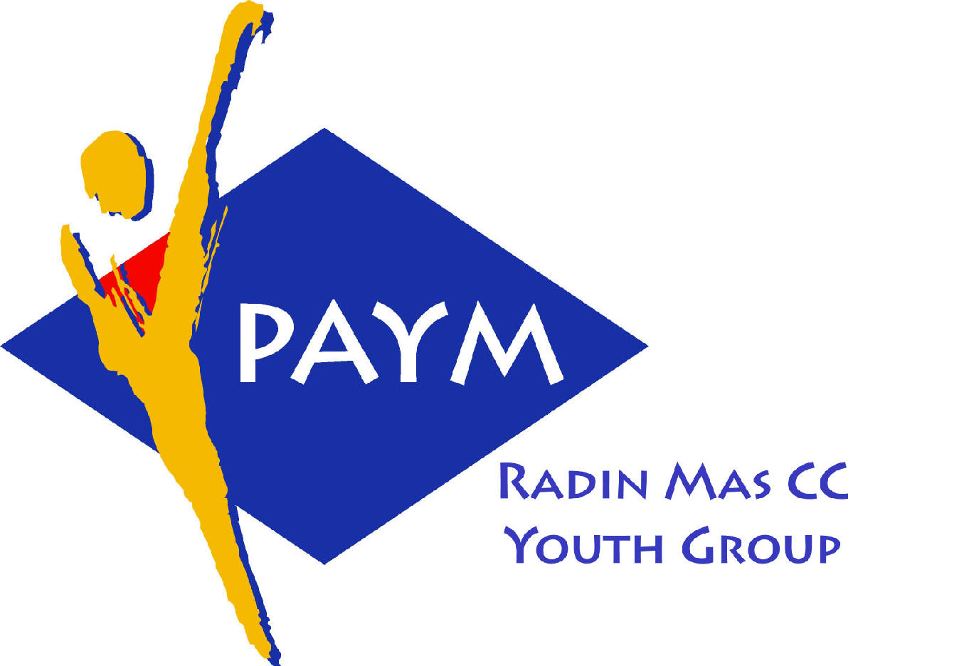
 Radin Mas Toastmasters Club

District: 51 Division: D Area: D1 Club No.: 4436
An Activity Group of Radin Mas YEC
1, Telok Blangah Crescent, Singapore 098915
Tel: (65) 6273 5294 Fax: (65) 62730768 E-mail: rm_tm@asiaone.com
http://www.rmtoastmasters.cjb.net.

Club Mission: To provide a mutually supportive and positive learning environment in which every member has the opportunity to develop communication and leadership skills, which in turn will foster self-confidence and personal growth.
_________________________________________________________________________________________________________

42nd Monthly Meeting of Radin Mas Toastmasters Club (2003/2004)
20th October 2003, Monday, 7.15 pm

Radin Mas Community Club, Level 2, Conference Room

4th Exco Committee  President  Roger Soh CTM  98489205  rogersoh@starhub.net.sg  Vice President Education  Tay Yiang Ping CL  96221803  yptay@starhub.net.sg  Airin Sugiono  97526774  Airin_sugiono@yahoo.com  Vice President Membership  Jackson Chua CL  90026464  tmjacksonchua@yahoo.com.sg  Yee Huat  Tyh_sg@yahoo.com  Vice President Publicity  Vico Lew Yue Wah  97505876  mombasasm@yahoo.com.sg  Secretary  Tan Chian Huay  Tan_Chian_Huay@moe.edu.sg  Treasurer  Panneer Selvam  98236334  pan17@singnet.com.sg  Sgt-at-arm  Thomas Lai Yew Fai  96800177  laiyf@yahoo.com  Immediate Past President  Vanni Cheong CTM  96174713  wanhoon@singnet.com.sg  Club Advisor:  Susan Wong DTM  Club Coaches:  David Chee, ATM-S  Lynn Desker DTM  Area D1 Governor:  Tay Yiang Ping CL  Our next meeting will be on  16 Nov 2003 (Monday)  We meet every 3rd Monday of  the month starting Oct 2003! | 7.15 pm | Reception and fellowship
 | 7.30 pm | SAA Warm Up Session |  | Simon Ong CTM
 | 7.40 pm | Toastmaster of the Evening |  | David Tan
 | 7.43 pm | Opening Speech |  | Roger Soh CL
 | 7.47 pm | Table Topics Session |  | Tay Yiang Ping CL
 | 8.02 pm | Timer Report |  | Roger Soh CL
 |  | Vote for Best Speaker
 |  | Prepared Speech session
 | 8.12 pm | P3 Organise Your Speech (5-7 mins) |  | Cynthia Lau**
 | 8.20 pm | AP1 Storytelling (5 - 7 mins) |  | Bruno CTM
 | 8.28 pm | Break
 | 8.48 pm | AP4 Speaking to Inform – A Fact-Finding Report (10-12 mins) |  | Tay Yiang Ping
 | 9.00 pm | AP2 The Professional Speaker – Speaking to Entertain (15-20 mins) |  | Jackson Chua CL
 | 9.20 pm | Timer Report |  | Roger Soh
 |  | Vote for Best Speaker
 |  | Evaluation ( 2-3 mins each) |  | David Tan
 | 9.22 pm
 | 9.26 pm | For Cynthia Lau |  | David Chee ATM-S CL
 | 9.30 pm | For Bruno |  | Susan Wong DTM
 | 9.34 pm | For Tay Yiang Ping |  | Anthony Leong DTM**
 | 9.38pm | For Jackson Chua |  | Lynn Desker DTM
 | 9.42pm | Timer Report |  | Roger Soh
 |  | Vote for Best Speaker
 | 9.43 pm | Language Evaluation |  | Tan May Yan CL**
 | 9.53 pm | Ah Counter |  | Simon Ong CTM
 | 9.55 pm | General Evaluator |  | John Sih DTM**
 | 10.05 pm | Closing Award and Home Sweet Home” |  | Roger Soh CL
 | ** External Guest:
 | Tan May Yan CL – Area B4 Governor  Bruno CTM - New Millenium TMC  David Tan CTM – New Millenium TMC  Simon Ong CTM – New Millenium TMC |  | John Sih DTM – Money Mastery TMC  Anthony Leong DTM – New Millenium TMC, President  Cynthia Lau, Sun Life TMC

