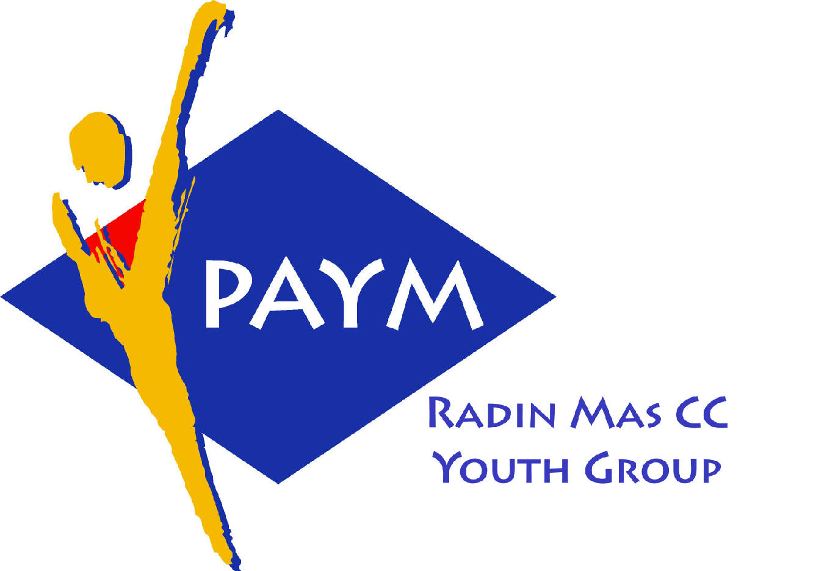
 Radin Mas Toastmasters Club

District: 80 Division: D Area: D1 Club No.: 4436
An Activity Group of Radin Mas YEC
1, Telok Blangah Crescent, Singapore 098915
Tel: (65) 6273 5294 Fax: (65) 62730768
http://www.geocities.com/rm_tmc
Club Mission: To provide a mutually supportive and positive learning environment in which every member has the opportunity to develop communication and leadership skills, this in turn will foster self-confidence and personal growth.
_____________________________________________________________________________________________________
55th Monthly Meeting of Radin Mas Toastmasters Club (2004/2005)
22nd November, Monday, 7.00 pm

Radin Mas Community Club, Level 2, Conference Room
5th Exco Committee  President  Vico Liew Yue Wah  97505876  mombasasm@yahoo.com.sg  Vice President Education  Thomas Lai Yew Fai  96800177  laiyf@yahoo.com  Vice President Membership  Tay Yiang Ping ATMB, CL  96221803  yptay@starhub.net.sg  Vice President Publicity  Gabriel Ho  91015751  Gabriel_hch@yahoo.com  Secretary  Chee Kim Loon, CTM  96980338  kimloon@singnet.com.sg  Treasurer  Roger Soh CL  98489205  rogersoh@starhub.net.sg  Sergeant-At-Arms  Russell Cheong  96910869  russellcheong@hotmail.com  Immediate Past President  Roger Soh CL  98489205  rogersoh@starhub.net.sg  Area D1 Governor:  Chee Kim Loon, CTM  Our next meeting  on 20 December (Monday)  We meet every 4th Monday of the month. | 7:00 pm | Reception and fellowship
 | 7:20 pm | SAA Warm Up Session | Teo Yee Lee
 | 7:28 pm | Toastmaster of the Evening | Eric Lau
 | 7:30pm | President Opening Address | Vico Liew
 | 7.35 pm | Word of the Day | Patricia Lim ATMS
 | 7:38pm | Table Topics | Margaret Lau
 | 7:54pm | Timer’s Report | Teo Yee Lee
 | 7:55pm | Induction Ceremony | Tay Yiang Ping ATMB CL
 |  | Prepared Speech session
 | 8:05 pm | P3: Organize Your Speech (5-7 mins) | Sik Ling Ling
 | 8:13pm | P4: Show What You Mean (5-7 mins) | Helen Ang
 | 8:21pm | P4: Show What You Mean (5-7 mins) | Philip Tan
 | 8:29pm | P7: Apply Your Skills (5-7 mins) | Thomas Lai
 | 8:36pm | Timer’s Report | Teo Yee Lee
 |  | Break
 |  | Evaluation ( 2-3 mins each)
 | 8:50pm | For Sik Ling Ling | Chee Kim Loon, CTM
 | 8:53pm | For Philip Tan | Jamie Lee, CTM
 | 8:56pm | For Helen Ang | Violet Lim CL
 | 9:00pm | For Thomas Lai | Tan Chuan Hoh ATMB CL
 | 9:03pm | Timer’s Report | Teo Yee Lee
 | 9:04pm | Ah Counter Report | Tay Yiang Ping ATMB CL
 | 9:06pm | Language Evaluation | Patricia Lim ATMS
 | 9.20pm | Closing Award & Address | Vico Liew
 | 9.25 pm | Home Sweet Home
Guests:
Violet Lim CL, Club President, Cairnhill TMC
Jamie Lee, AG D3, CTM, IPP Cairnhill TMC
Tan Chuan Hoh ATMB CL, Queenstown TMC
Patricia Lim, ATMS CL, SIMI TMC
Announcement:
KL 2004, District 51 & 80 Semi-Annual Convention 26th – 28th Nov 2004

