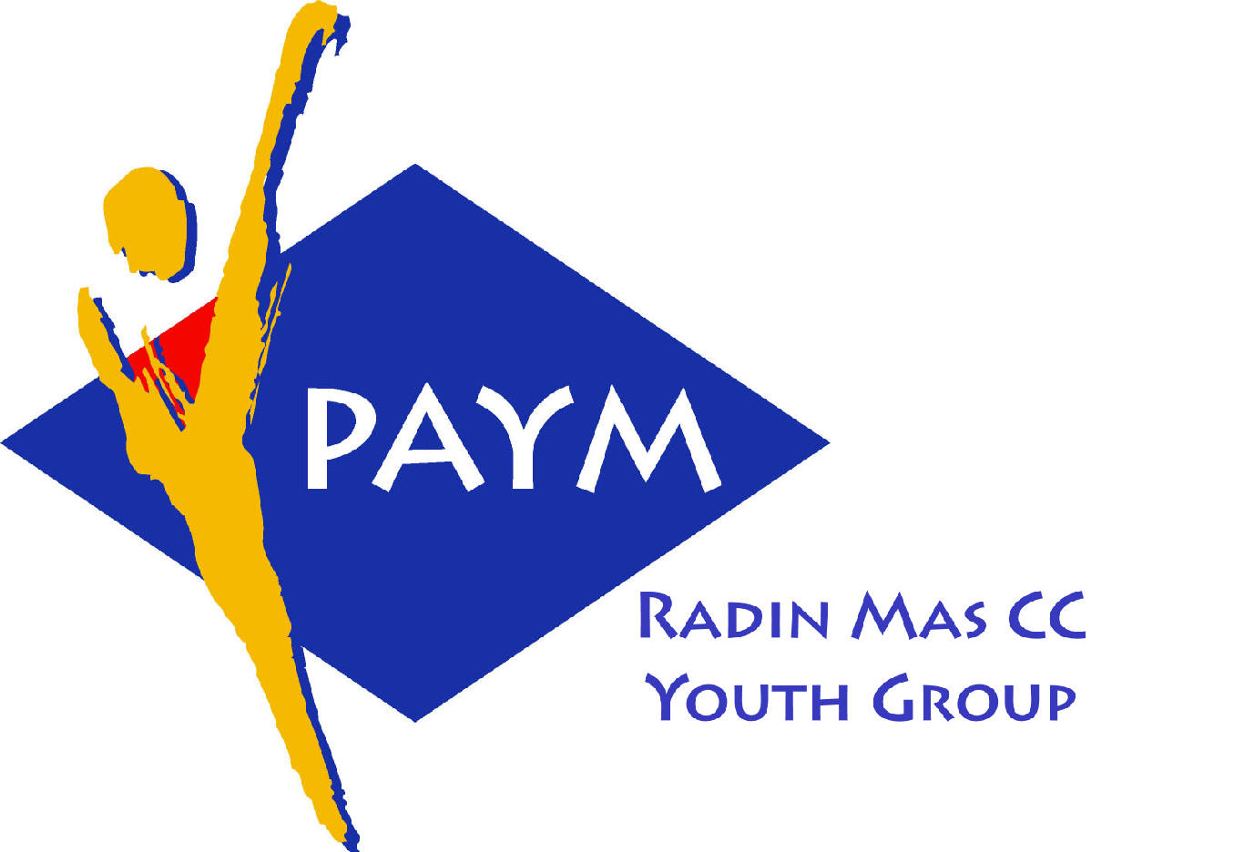
 Radin Mas Toastmasters Club

District: 51 Division: D Area: D1 Club No.: 4436
An Activity Group of Radin Mas YEC
1, Telok Blangah Crescent, Singapore 098915
Tel: (65) 6273 5294 Fax: (65) 62730768
http://www.geocities.com/rm_tmc

Club Mission: To provide a mutually supportive and positive learning environment in which every member has the opportunity to develop communication and leadership skills, which in turn will foster self-confidence and personal growth.
_________________________________________________________________________________________________________

43rd Monthly Meeting of Radin Mas Toastmasters Club (2003/2004)
24th November 2003, Monday, 7..00 pm

Radin Mas Community Club, Level 2, Conference Room

4th Exco Committee  President  Roger Soh CTM  98489205  rogersoh@starhub.net.sg  Vice President Education  Tay Yiang Ping CL  96221803  yptay@starhub.net.sg  Airin Sugiono  97526774  Airin_sugiono@yahoo.com  Vice President Membership  Jackson Chua CL  90026464  tmjacksonchua@yahoo.com.sg  Vice President Publicity  Vico Lew Yue Wah  97505876  mombasasm@yahoo.com.sg  Secretary  Treasurer  Panneer Selvam  98236334  pan17@singnet.com.sg  Sgt-at-arm  Thomas Lai Yew Fai  96800177  laiyf@yahoo.com  Immediate Past President  Vanni Cheong CTM  96174713  wanhoon@singnet.com.sg  Club Advisor:  Susan Wong DTM  Club Coaches:  David Chee, ATM-S  Lynn Desker DTM  Area D1 Governor:  Tay Yiang Ping CL  Our next meeting  on 15 Dec 2003 (Monday)  and  OPEN HOUSE  On 21 Dec 2003 (Sunday)  We meet every 3rd Monday of  the month. | 7.00 pm | Reception and fellowship
 | 7.30 pm | SAA Warm Up Session |  | Thomas Lai
 | 7.38 pm | Toastmaster of the Evening |  | David Chee ATM-S, CL
 | 7.42 pm | Word of the Day |  | Chong Cheng Lee ATM-S CL
 | 7.43 pm | Table Topics Session |  | Vico Lew
 | 8.03 pm | Timer Report |  | Eskay Ng CTM
 |  | Vote for Best Speaker
 |  | Prepared Speech session
 | 8.05 pm | P2 Speak with Sincerity ( 5-7 mins) |  | Thomas Lai
 | 8.13 pm | AP1 Speeches by Management –  The Briefing (8-10mins) |  | Bruno CTM
 | 8.28 pm | AP3 Speaking to Inform –  The Demonstration Talk (8-10mins) |  | Tay Yiang Ping
 | 8.40 pm | Timer Report |  | Eskay Ng CTM
 |  | Vote for Best Speaker
 |  | Break
 | 9.00 pm | Evaluation ( 2-3 mins each) |  | David Chee ATM-S, CL
 | 9.02 pm | For Thomas Lai |  | Bruno CTM
 | 9.06 pm | For Bruno |  | Seah Soon Huat CTM
 | 9.10 pm | For Tay Yiang Ping |  | Michael Wee DTM
 | 9.14pm | Timer Report |  | Eskay Ng CTM
 |  | Vote for Best Speaker
 | 9.15 pm | Language Evaluation |  | Chong Cheng Lee ATM-S CL
 | 9.25 pm | General Evaluator |  | Susan Wong DTM
 | 9.35 pm | Ah Counter |  | Ranmilie
 | 9.38 pm | Closing Award and Home Sweet Home” |  | Tay Yiang Ping CL
 | ** External Guest:
 | Eskay Ng CTM – Sky Media TMC  Seah Soon Huat CTM – Sky Media TMC |  | Michael Wee DTM – Tampines Changkat TMC  Chong Cheng Lee ATM-S, CL - Tampines Changkat TMC  Bruno CTM - Tampines Changkat / New Millenium TMC

