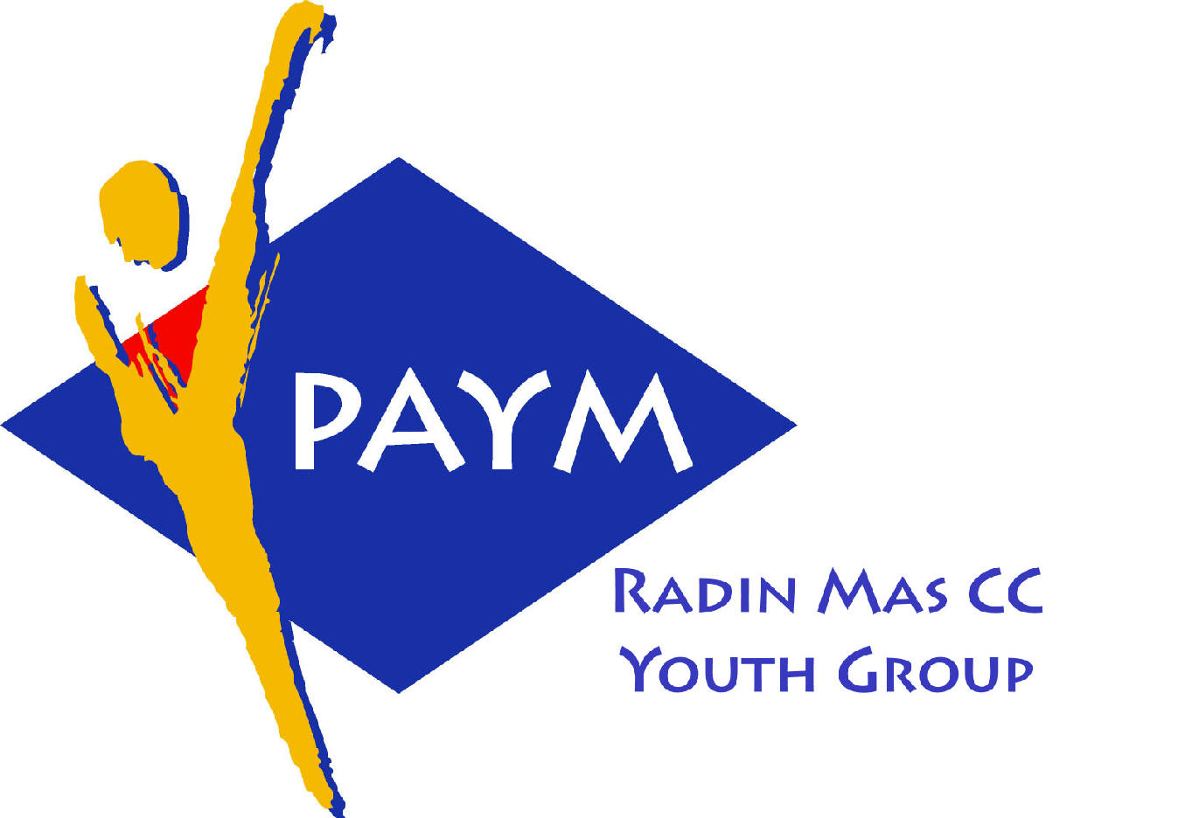

Radin Mas Toastmasters Club

District. 80 Division. D Area. D1 Club No.. 4436
An Activity Group of Radin Mas YEC
1, Telok Blangah Crescent, Singapore 098915
Tel. (65) 6273 5294 Fax. (65) 62730768
http.//www.geocities.com/rm_tmc
Club Mission. To provide a mutually supportive and positive learning environment in which every member has the opportunity to develop communication and leadership skills, this in turn will foster self-confidence and personal growth.
_____________________________________________________________________________________________________
61st Monthly Meeting of Radin Mas Toastmasters Club (2004/2005)
30th May, Monday, 7.00 pm

Radin Mas Community Club, Level 2, Conference Room
5th Exco Committee  President  Vico Lew Yue Wah  97505876  mombasasm@yahoo.com.sg  Vice President Education  Thomas Lai Yew Fai, CTM  96800177  laiyf@yahoo.com  Vice President Membership  Tay Yiang Ping ATMB, CL  96221803  yptay@starhub.net.sg  Vice President Publicity  Gabriel Ho  91015751  Gabriel_hch@yahoo.com  Secretary  Chee Kim Loon, CTM  96980338  kimloon@singnet.com.sg  Treasurer  Roger Soh CL  98489205  rogersoh@starhub.net.sg  Sergeant-At-Arms  Russell Cheong  96910869  russellcheong@hotmail.com  Immediate Past President  Roger Soh CL  98489205  rogersoh@starhub.net.sg  Area D1 Governor.  Chee Kim Loon, CTM  Our next meeting  on 27 June (Monday)  We meet every 4th Monday of the month. | 07:00 pm | Reception and fellowship
 | 07:20 pm | SAA Warm Up Session |  | Lee Deek Ann
 | 07:30 pm | Toastmaster of the Evening |  | Thomas Lai CTM
 | 07:35 pm | Word of the Day |  | James Wong
 | 07:38 pm | Club President Opening Address |  | Vico Liew
 | 07:41 pm | Table Topic |  | Tay Yiang Ping ATMB, CL
 | 07:53 pm | Timer's Report |  | Chee Kim Loon, CTM
 | 07:54 pm | Vote for Best Speaker |  | Lee Deek Ann
 |  | Prepared Speech session |  | Thomas Lai CTM
 | 07:56 pm | P1 Ice Breaker |  | Trixi Lim
 | 08:07 pm | P4 How to Say it |  | Ng Wei Lin
 | 08:15 pm | P4 How to Say it |  | Kelvin Wong
 | 08:23 pm | P9 Persuade With Power |  | Russell Cheong
 | 08:31 pm | Timer's Report |  | Chee Kim Loon, CTM
 | 08:32 pm | Vote for Best Speaker |  | Lee Deek Ann
 | 08:34 pm | Break |  | Thomas Lai CTM
 | 08:49 pm | AGM |  | Vico Liew
 |  | Evaluation ( 2-3 mins each) |  | Thomas Lai CTM
 | 09:09 pm | Evaluation for Trixi Lim |  | Lee Khim Song
 | 09:13 pm | Evaluation for Ng Wei Lin |  | Helen Ang
 | 09:17 pm | Evaluation for Kelvin Wong |  | Tay Yiang Ping ATMB, CL
 | 09:21 pm | Evaluation for Russel Cheong |  | David Goh ATMS
 | 09:25 pm | Timer’s Report |  | Chee Kim Loon, CTM CL
 | 09:26 pm | Vote for Best Evaluator |  | Lee Deek Ann
 | 09:28 pm | Language Evaluation |  | James Wong
 | 09.38 pm | Ah Counter |  | Lim Hong Chin
 | 09:41 pm | Closing Award & Address |  | Vico Lew
 | 09:45 pm | Home Sweet Home
Guests
David Goh ATMS CL,Toa Payoh Central CC TMC
Lee Khim Song,Toa Payoh Central CC TMC

James Wong DTM, First Gourmet & Enliven Singapore TMC

