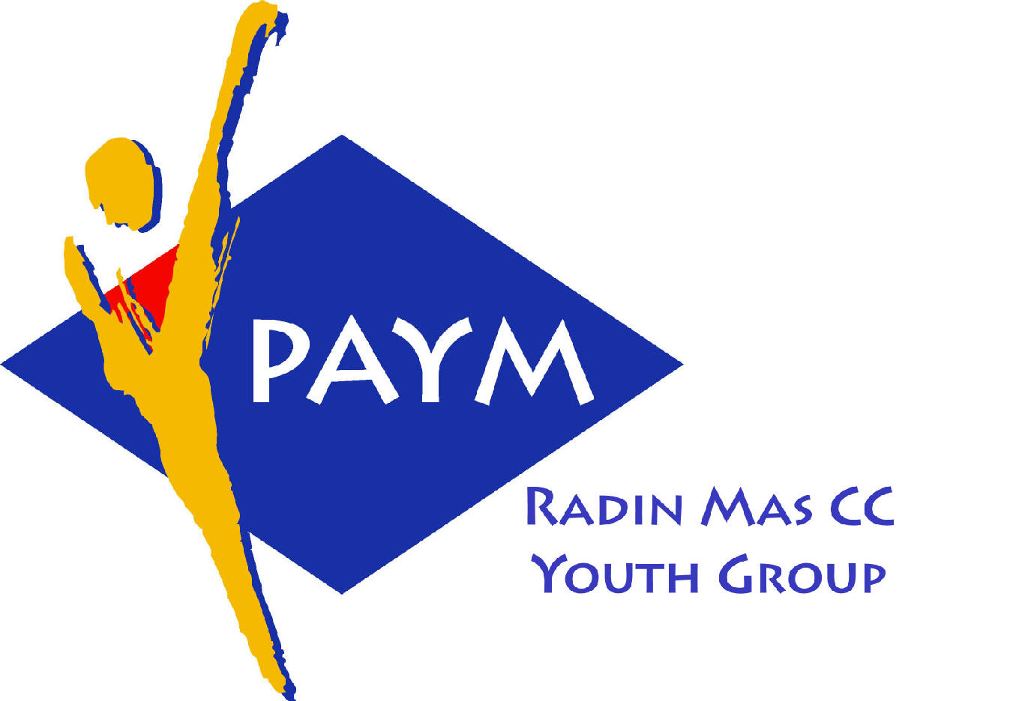
 Radin Mas Toastmasters Club

District. 80 Division. D Area. D1 Club No.. 4436
An Activity Group of Radin Mas YEC
1, Telok Blangah Crescent, Singapore 098915
Tel. (65) 6273 5294 Fax. (65) 62730768
http.//www.geocities.com/rm_tmc
Club Mission. To provide a mutually supportive and positive learning environment in which every member has the opportunity to develop communication and leadership skills, this in turn will foster self-confidence and personal growth.
_____________________________________________________________________________________________________
59th Monthly Meeting of Radin Mas Toastmasters Club (2004/2005)
28th March, Monday, 7.00 pm

Radin Mas Community Club, Level 2, Conference Room
5th Exco Committee  President  Vico Liew Yue Wah  97505876  mombasasm@yahoo.com.sg  Vice President Education  Thomas Lai Yew Fai  96800177  laiyf@yahoo.com  Vice President Membership  Tay Yiang Ping ATMB, CL  96221803  yptay@starhub.net.sg  Vice President Publicity  Gabriel Ho  91015751  Gabriel_hch@yahoo.com  Secretary  Chee Kim Loon, CTM  96980338  kimloon@singnet.com.sg  Treasurer  Roger Soh CL  98489205  rogersoh@starhub.net.sg  Sergeant-At-Arms  Russell Cheong  96910869  russellcheong@hotmail.com  Immediate Past President  Roger Soh CL  98489205  rogersoh@starhub.net.sg  Club Advisor.  Susan Wong DTM  Club Coaches.  David Chee, ATM-S, CL  Lynn Desker DTM  Area D1 Governor.  Chee Kim Loon, CTM  Our next meeting  on 25 April (Monday)  We meet every 4th Monday of the month. | 7.00 pm | Reception and fellowship
 | 7.20 pm | SAA Warm Up Session |  | Yvonne Chai
 | 7.30 pm | Toastmaster of the Evening |  | Yeo E Yong
 | 7.35 pm | Word of the Day |  | Seah Soon Huat CTM
 | 7.38pm | Table Topics |  | Eric Lau
 | 8.00 pm | Timer’s Report |  | Ng Wei Lin
 |  | Vote for Best Table Topics Speaker |  | Yvonne Chai
 |  | Prepared Speech session |  | Yeo E Yong
 | 8.03 pm | P1. Ice Breaker (4-6 mins) |  | Trixi Lim
 | 8.11pm | P5. Your Body Speaks (5-7 mins) |  | Sik Ling Ling
 | 8.19pm | P6. Vocal Variety (5-7min) |  | Helen Ang
 | 8.27pm | P6. Vocal Variety (5-7min) |  | Russell Cheong
 | 8.35pm | P9. Persuade With Power(5-7mins) |  | Thomas Lai
 | 8.43pm | Timer’s Report |  | Ng Wei Lin
 |  | Vote for Best Speaker
 |  | Break
 |  | Evaluation ( 2-3 mins each) |  | Yeo E Yong
 | 9.00 pm | For Trixi |  | Tay Yiang Ping, ATMB CL
 | 9.04 pm | For Sik Ling Ling |  | Eric Lau
 | 9.08 pm | For Helen Ang |  | Lim Mui Huan
 | 9.12 pm | For Russell Chong |  | Chee Kim Loon, CL
 | 9.16 pm | For Thomas Lai |  | S Narayanaswamy ATMB CL
 | 9.20 pm | Timer’s Report |  | Ng Wei Lin
 |  | Vote for Best Evaluator
 | 9.21 pm | Language Evaluation |  | Seah Soon Huat CTM
 | 9.30pm | Closing Award & Address |  | Thomas Lai
 | 9.35 pm | Home Sweet Home
 | Guests  S Narayanaswamy ATMB CL Singapore Tamil TMC  Yeo E Yong, Toa Payoh Central TMC  Lim Mui Huan, Toa Payoh Central TMC  Seah Soon Huat CTM, Toa Payoh Central TMC  Ng Wei Lin |  | Announcement:  Division D Contests, “The Best of The Best”  - 16th April at Queenstown CC  District 80 Toastmasters Awareness Month  - March  Speechcraft 2nd intake: Apr 15, 22 May 6, 13, 23
Last meeting on 28th Feburary 2005
Congratulations to Vico Lew awarded the Best Table Topics Speaker!
Congratulations to Philip Tan awarded the Best Prepared Speech Speaker!
Congratulations to Lily Lim awarded the Best Evaluator!

