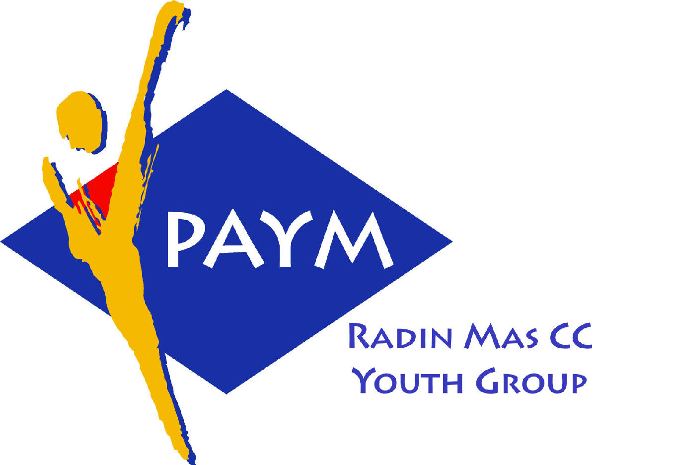
 Radin Mas Toastmasters Club

District: 51 Division: D Area: D1 Club No.: 4436
An Activity Group of Radin Mas YEC
1, Telok Blangah Crescent, Singapore 098915
Tel: (65) 6273 5294 Fax: (65) 62730768
http://www.geocities.com/rm_tmc

Club Mission: To provide a mutually supportive and positive learning environment in which every member has the opportunity to develop communication and leadership skills, which in turn will foster self-confidence and personal growth.
_________________________________________________________________________________________________________

47th Monthly Meeting of Radin Mas Toastmasters Club (2003/2004)
15th March, Monday, 7.00 pm

Radin Mas Community Club, Level 2, Conference Room
"She's on a Role!"
Interanational Women’s Day 8th Mar 2004
4th Exco Committee  President  Roger Soh CTM  98489205  rogersoh@starhub.net.sg  Vice President Education  Tay Yiang Ping CL  96221803  yptay@starhub.net.sg  Airin Sugiono  97526774  Airin_sugiono@yahoo.com  Vice President Membership  Jackson Chua CL  90026464  tmjacksonchua@yahoo.com.sg  Vice President Publicity  Vico Lew Yue Wah  97505876  mombasasm@yahoo.com.sg  Secretary  Treasurer  Panneer Selvam  98236334  pan17@singnet.com.sg  Sgt-at-arm  Thomas Lai Yew Fai  96800177  laiyf@yahoo.com  Immediate Past President  Vanni Cheong CTM  96174713  wanhoon@singnet.com.sg  Club Advisor:  Susan Wong DTM  Club Coaches:  David Chee, ATM-S, CL  Lynn Desker DTM  Area D1 Governor:  Tay Yiang Ping CL  Our next meeting  on 26 April 2004 (Monday)  We meet every 4th Monday of the month. | 7.00 pm | Reception and fellowship
 | 7.20 pm | SAA Warm Up Session | Vico Lew CL
 | 7.28 pm | Toastmaster of the Evening | Thomas Lai
 | 7.30 pm | Word of the Day | Bruno ATM-B, CL
 | 7.35 pm | Table Topics Session | Chee Kim Loon, CTM
 | 7.58 pm | Timer Report | Jasmine Tan
 |  | Vote for Best Speaker
 |  | Part I - Prepared Speech session | Thomas Lai
 | 8.00 pm | AP2 Interpretive Reading (6-8 mins) | Jackson Chua CL
 | 8.09 pm | Area D2 Contest Champion Speech (5-7mins) | Lynn Desker DTM
 |  | Evaluation ( 2-3 mins each)
 | 8.17 pm | For Jackson Chua | Anthony Leong DTM
 | 8.21 pm | Break | Vico Lew CL
 |  | Part II - Prepared Speech session | Thomas Lai
 | 8.40 pm | P1 The Ice Breaker (4-6 mins) | Russell Cheong
 | 8.48 pm | P1 The Ice Breaker (4-6 mins) | Gabriel Ho
 | 8.56 pm | P3 Organize Your Speech (5-7 mins) | Ranmilie
 |  | Evaluation ( 2-3 mins each)
 | 8.57 pm | For Russell Cheong | David Chee ATM-S, CL
 | 9.01 pm | For Gabriel Ho | Vanni Cheong ATM-B, CL
 | 9.05 pm | For Ranmilie | Chan Boon Hwee ATM-B CL
 | 9.09 pm | Timer Report | Jasmine Tan
 | 9.10 pm | For Lynn Desker | All
 | 9.20 pm | Language Evaluation | Bruno ATM-B, CL
 | 9.30 pm | Ah Counter | Tay Yiang Ping CL
 | 9.31 pm | Closing Award & Address by VPPR | Vico Lew CL
External Guest:
Chan Boon Hwee, ATM-B. CL: Brilliant Adv TMC and Alumni TMC
Bruno ATM-B, CL: New Millenium Adv TMC and Tampines Changkat TMC
Anthony Leong DTM : New Millenium Adv TMC
Chee Kim Loon CTM: Queenstown TMC
Announcement
Area D1 International Speech & Table Topics Contest
22 Mar 2004 (Monday), SIA Training Centre, 720 Upper Changi Road East
Please come and support our Club Representative for Area D1 Contest
Table Topics: Vico Lew and Ranmilie
International Speech: Vico Lew and Vanni Cheong

