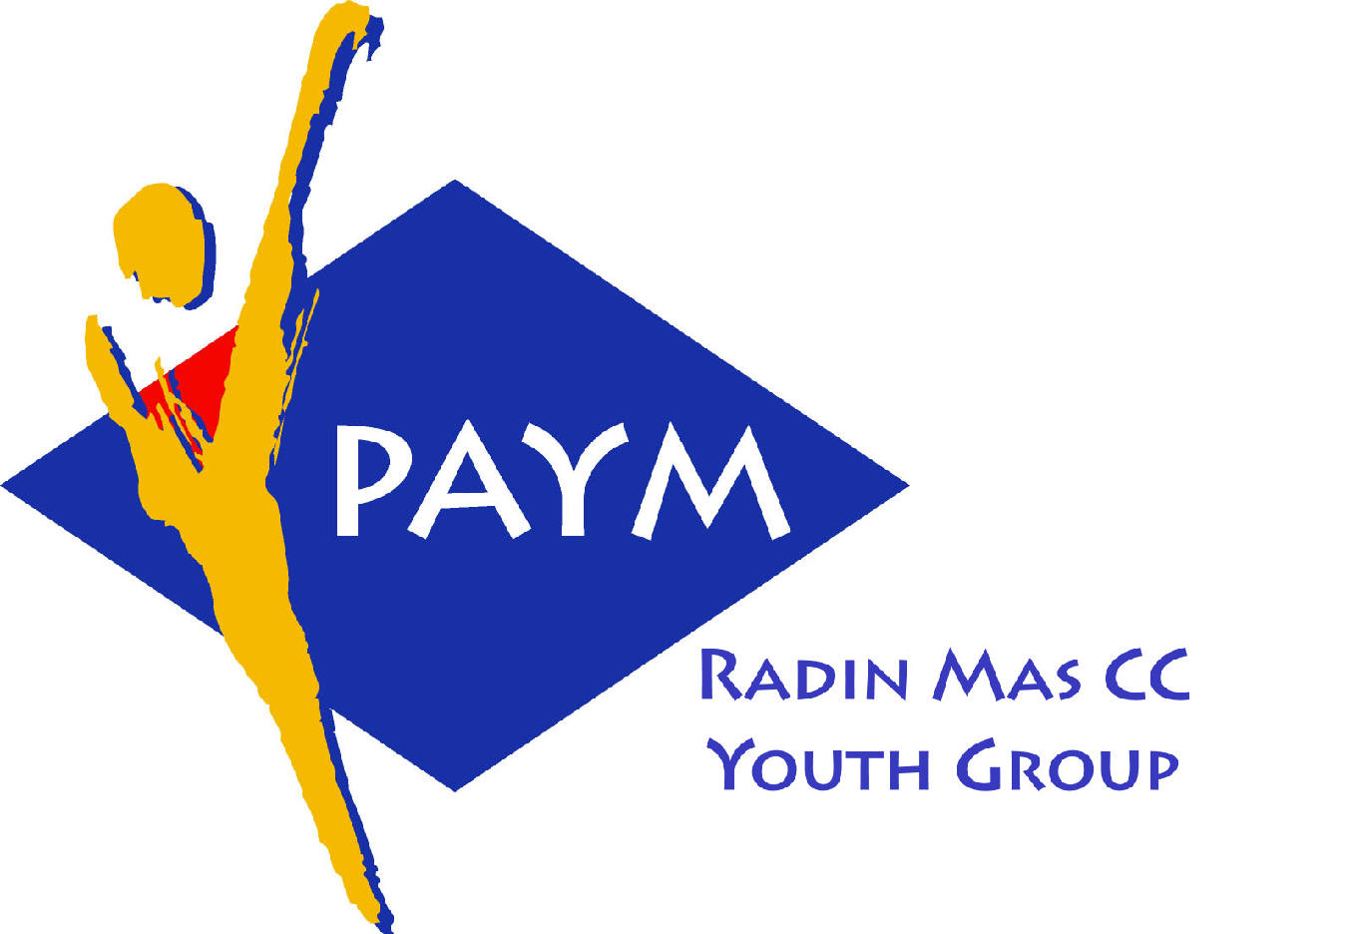
 Radin Mas Toastmasters Club

District: 51 Division: D Area: D1 Club No.: 4436
An Activity Group of Radin Mas YEC
1, Telok Blangah Crescent, Singapore 098915
Tel: (65) 6273 5294 Fax: (65) 62730768
http://www.geocities.com/rm_tmc
Club Mission: To provide a mutually supportive and positive learning environment in which every member has the opportunity to develop communication and leadership skills, this in turn will foster self-confidence and personal growth.
_____________________________________________________________________________________________________
50th Monthly Meeting of Radin Mas Toastmasters Club (2003/2004)
24th June, Monday, 7.00 pm

Radin Mas Community Club, Level 2, Conference Room
4th Exco Committee  President  Roger Soh CTM  98489205  rogersoh@starhub.net.sg  Vice President Education  Tay Yiang Ping CL  96221803  yptay@starhub.net.sg  Airin Sugiono  97526774  Airin_sugiono@yahoo.com  Vice President Membership  Jackson Chua CL  90026464  tmjacksonchua@yahoo.com.sg  Vice President Publicity  Vico Lew Yue Wah  97505876  mombasasm@yahoo.com.sg  Secretary  Treasurer  Panneer Selvam  98236334  pan17@singnet.com.sg  Sgt-at-arm  Thomas Lai Yew Fai  96800177  laiyf@yahoo.com  Immediate Past President  Vanni Cheong CTM  96174713  wanhoon@singnet.com.sg  Club Advisor:  Susan Wong DTM  Club Coaches:  David Chee, ATM-S, CL  Lynn Desker DTM  Area D1 Governor:  Tay Yiang Ping CL  Our next meeting  on 26th July 2004 (Monday)  We meet every 4th Monday of the month. | 7.00 pm | Reception and fellowship
 | 7.20 pm | SAA Warm Up Session | Russell Cheong
 | 7.28 pm | Toastmaster of the Evening – 1st Session | Marshal Lee ATM-B, CL
 | 7.30 pm | Word of the Day | Ong Sin Tiong ATM-B, AL
 | 7.33 pm | Opening Address by Club President | Roger Soh CL
 | 7.38 pm | Table Topics Session | Thomas Lai
 | 7.58 pm | Timer Report | TBA
 |  | Vote for Best Speaker
 |  | Prepared Speech session | Marshal Lee ATM-B, CL
 | 8.00 pm | P3 – Get to the Point (5-7 mins) | Gabriel Ho
 | 8.08 pm | AP2 – Public Relations  Resources for Goodwill (8-10 mins) | Jackson Chua ATM-S
 | 8.19pm | AP10 – Speeches By Management –  Confrontation: The Adversary Relationship (15 mins) | Tay Yiang Ping
 | 8.35 pm | Timer Report | TBA
 | 8.36 pm | Break | Russell Cheong
 |  | Evaluation ( 2-3 mins each)
 |  | Toastmaster of the Evening – 2nd Session | Marshal Lee ATM-B, CL
 | 9.00pm | For Gabriel Ho | Roger Soh CL
 | 9.04 pm | For Jackson Chua | David Chee ATM-S,CL
 | 9.08 pm | For Tay Yiang Ping | Lynn Desker DTM
 | 9.12 pm | Timer Report | TBA
 | 9.12 pm | Language Evaluation | Ong Sin Tiong ATM-B, AL
 | 9.22 pm | Genernal Evaluation | Willy Tan CL
 | 9.32 pm | Ah Counter | Chee Kim Loon CL
 | 9.35 pm | Closing Award & Address | Roger Soh CL
 | 9.40 pm | Home Sweet Home
External Guest:
Marshal Lee ATM-B, CL Soaring Eagle TMC
Willy Tan CL, Skymedia TMC
Ong Sin Tiong ATM-B, CL : Billiance Advance TMC, Queenstown English and Mandarin TMC
Last Meeting Awards
Best Table Topics – Chong John
Announcement:
World Champion Public Speaker – Presenter’s Bootcamp – 10th July
1st Club Officers Training – 24th July

**Welcome our new member – Chee Kim Loon CL, Incoming Area D1 Governor

