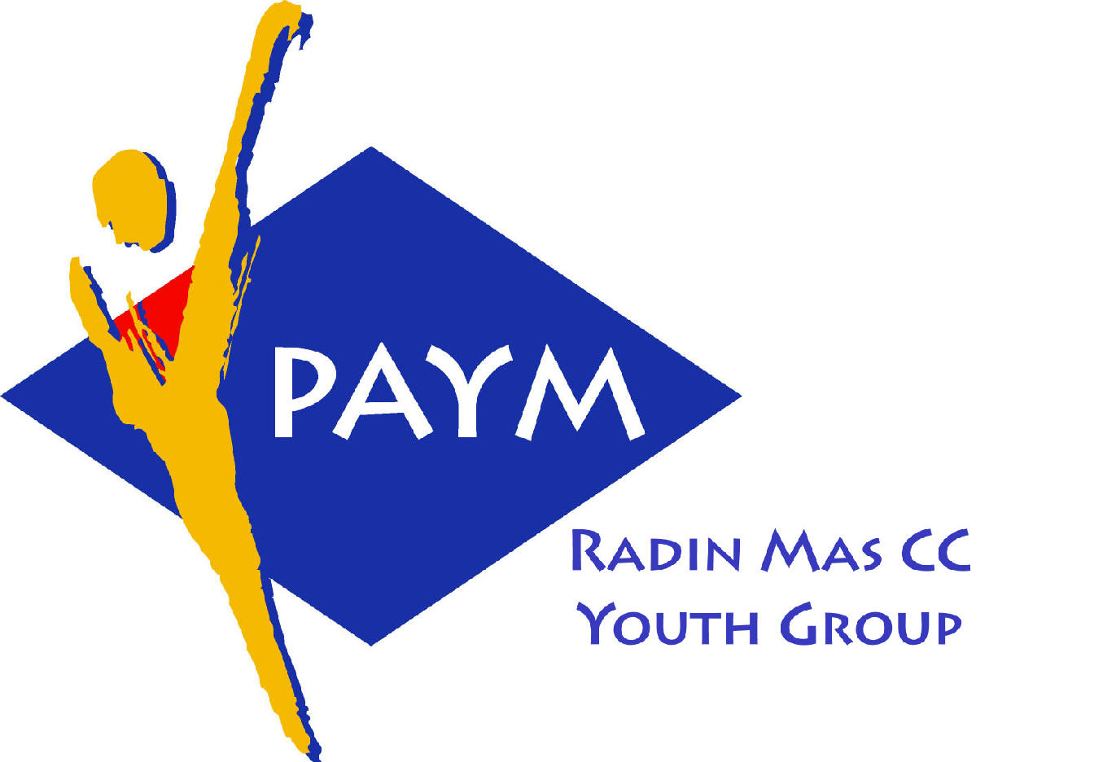
 Radin Mas Toastmasters Club

District: 51 Division: D Area: D1 Club No.: 4436
An Activity Group of Radin Mas YEC
1, Telok Blangah Crescent, Singapore 098915
Tel: (65) 6273 5294 Fax: (65) 62730768
http://www.geocities.com/rm_tmc
Club Mission: To provide a mutually supportive and positive learning environment in which every member has the opportunity to develop communication and leadership skills, this in turn will foster self-confidence and personal growth.
_____________________________________________________________________________________________________
51st Monthly Meeting of Radin Mas Toastmasters Club (2004/2005)
26th July, Monday, 7.00 pm

Radin Mas Community Club, Level 2, Conference Room
5th Exco Committee  President  Vico Lew Yue Wah  97505876  mombasasm@yahoo.com.sg  Vice President Education  Thomas Lai Yew Fai  96800177  laiyf@yahoo.com  Vice President Membership  Tay Yiang Ping ATMB, CL  96221803  yptay@starhub.net.sg  Vice President Publicity  Gabriel Ho  91015751  Gabriel_hch@yahoo.com  Secretary  Chee Kim Loon, CTM  96980338  kimloon@singnet.com.sg  Treasurer  Roger Soh CL  98489205  rogersoh@starhub.net.sg  Sgt-at-arm  Russell Cheong  96910869  russellcheong@hotmail.com  Immediate Past President  Roger Soh CL  98489205  rogersoh@starhub.net.sg  Club Advisor:  Susan Wong DTM  Club Coaches:  David Chee, ATM-S, CL  Lynn Desker DTM  Area D1 Governor:  Chee Kim Loon, CTM  Our next meeting  on 23 August 2004 (Monday)  We meet every 4th Monday of the month. | 7.00 pm | Reception and fellowship
 | 7.20 pm | SAA Warm Up Session | Thomas Lai
 | 7.28 pm | Toastmaster of the Evening | Bruno Pereira ATMS, CL
 | 7.30 pm | Word of the Day | Marshall Lee ATMB, CL
 |  | Prepared Speech session
 | 7:35pm | P3 - Get To The Point (5-7 mins) | Russell Cheong
 | 7:42pm | AP1 – The Goodwill Speech (5-7 mins) | Lynn Desker DTM
 | 7:50pm | Timer Report | Yvonne Chai
 | 7:51pm | Special Talk – How to Control Fear in Public Speaking | Anthony Leong DTM
 |  | Evaluation ( 2-3 mins each)
 | 8:21pm | For Russell | Karunakaran
 | 8:25pm | For Lynn | Daniel Goh, CL
 | 8:30pm | Timer Report | Yvonne Chai
 | 8:31pm | Break
 |  | Installation Night
 | 8:55 pm | Immediate Past President Speech | Roger Soh CL
 | 9:00 pm | Immediate Past Area Governor D1 Speech | Tay Yiang Ping ATMB, CL
 | 9:03 pm | Club Coach Speech | Lynn Desker DTM
 | 9:06 pm | Club Coach Speech | David Chee ATM-S, CL
 | 9:09 pm | Installation of New Exco Officers | David Chee DTM
 | 9:25 pm | Club President Inauguration Speech | Vico Lew
 | 9:30 pm | Area Governor D1 Speech | Chee Kim Loon, CTM
 | 9:33pm | Language Evaluation | Marshall Lee ATMB, CL
 | 9.43pm | Closing Award & Address | Vico Lew
 | 9.45 pm | Home Sweet Home
External Guest:
Karunakaran, The Cultural Society, New Millennium Adv
Bruno Pereira ATMS, CL, Tampines Changkat, New Millennium Adv
Anthony Leong DTM, New Millennium Adv
David Chee ATMS CL, New Millennium Adv
Daniel Goh, Tampines Changkat TMC
Last Meeting Awards
Best Table Topics: Dickson Tang (Guest)
Best Prepared Speech: Gabriel Ho
Announcement:
Conducting Quality Contests – 7th August 2004, Saturday
Secrets to Successful Speech Communication – 14th August 2004, Saturday
**Welcome our new member – Yvonne Chai

