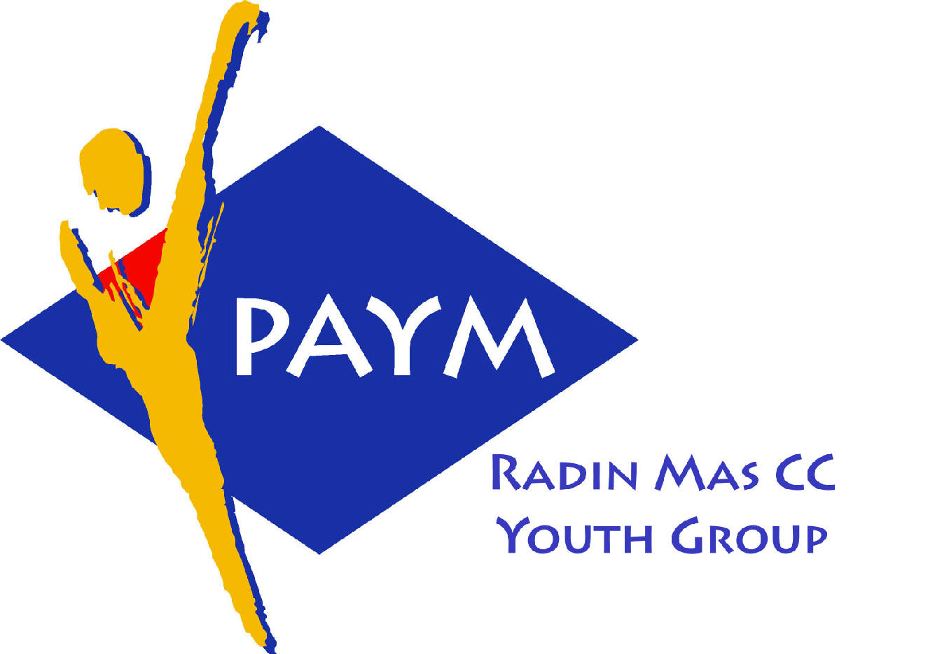
 Radin Mas Toastmasters Club

District: 51 Division: D Area: D1 Club No.: 4436
An Activity Group of Radin Mas YEC
1, Telok Blangah Crescent, Singapore 098915
Tel: (65) 6273 5294 Fax: (65) 62730768
http://www.geocities.com/rm_tmc

Club Mission: To provide a mutually supportive and positive learning environment in which every member has the opportunity to develop communication and leadership skills, which in turn will foster self-confidence and personal growth.
_________________________________________________________________________________________________________

45th Monthly Meeting of Radin Mas Toastmasters Club (2003/2004)
26th January, Monday, 7.00 pm

Radin Mas Community Club, Level 2, Conference Room

4th Exco Committee  President  Roger Soh CTM  98489205  rogersoh@starhub.net.sg  Vice President Education  Tay Yiang Ping CL  96221803  yptay@starhub.net.sg  Airin Sugiono  97526774  Airin_sugiono@yahoo.com  Vice President Membership  Jackson Chua CL  90026464  tmjacksonchua@yahoo.com.sg  Vice President Publicity  Vico Lew Yue Wah  97505876  mombasasm@yahoo.com.sg  Secretary  Treasurer  Panneer Selvam  98236334  pan17@singnet.com.sg  Sgt-at-arm  Thomas Lai Yew Fai  96800177  laiyf@yahoo.com  Immediate Past President  Vanni Cheong CTM  96174713  wanhoon@singnet.com.sg  Club Advisor:  Susan Wong DTM  Club Coaches:  David Chee, ATM-S  Lynn Desker DTM  Area D1 Governor:  Tay Yiang Ping CL  Our next meeting  on 23 Feb 2004 (Monday)  We meet every 4th Monday of  the month. | 7.00 pm | Reception and fellowship
 | 7.30 pm | SAA Warm Up Session |  | Rebekah Lee
 | 7.38 pm | Toastmaster of the Evening |  | Anthony Leong DTM
 | 7.40 pm | Word of the Day |  | Suzanne Cheong-Foo CTM
 | 7.42 pm | Opening Address by Club President |  | Roger Soh CL
 | 7.45 pm | Table Topics Session |  | Teresa Sng ATM-B
 | 8.05 pm | Timer Report |  | Tan Choong Song DTM
 |  | Vote for Best Speaker
 |  | Special Talk
 | 8.06 pm | “Elements of Good Speech” |  | David Chee ATM-S CL
 |  | Prepared Speech session
 | 8.35 pm | P6 Work with Words ( 5-7 mins) |  | Ng Mui Choo
 | 8.43 pm | Inspiration Speech by International Speech Contest Champion of Tampines Changkat TMC (5-7 mins) |  | Bruno ATM-B, CL
 |  | Timer Report |  | Tan Choong Song DTM
 | 8.51 pm | Break – “Lou Yu Sheng” (raw fish salad) - to bring Luck and Prosperous for Lunar New Year 2004 |  | Rebekah Lee
 |  | Evaluation ( 2-3 mins each) |  | Anthony Leong DTM
 | 9.20 pm | For Ng Mui Choo |  | Clara Chang DTM
 | 9.24 pm | For Vanni Cheong |  | Lynn Desker DTM
 | 9.28 pm | Timer Report |  | Tan Choon Song DTM
 | 9.30 pm | Language Evaluation |  | Suzanne Cheong-Foo CTM
 | 9.40 pm | Ah Counter |  | Catherine Goh
 | 9.42 pm | Introduction To Toastmasters |  | Tay Yiang Ping CL
 | 9.52pm | Q & A and Signing Up New Members |  | David Chee/Tay Yiang Ping
 | 10.00 pm | Closing Award & Address by Club President |  | Roger Soh CL
 | ** External Guest:
 | Ng Mui Choo – Sky Media TMC  Suzanne Cheong-Foo CTM – Sky Media TMC  Clara Chang DTM – NOL & Pan Excellence TMC  Rebekah Lee – YMCA TMC  Catherine Goh – Raffles Town Club TMC |  | Bruno ATMB,CL – Tampines Changkat /New Millennium Advance TMC  Anthony Leong DTM –New Millennium Advance TMC  Tan Choong Song DTM - Tao Payoh South TMC  Teresa Sng ATM-B – New Millennium TMC

