
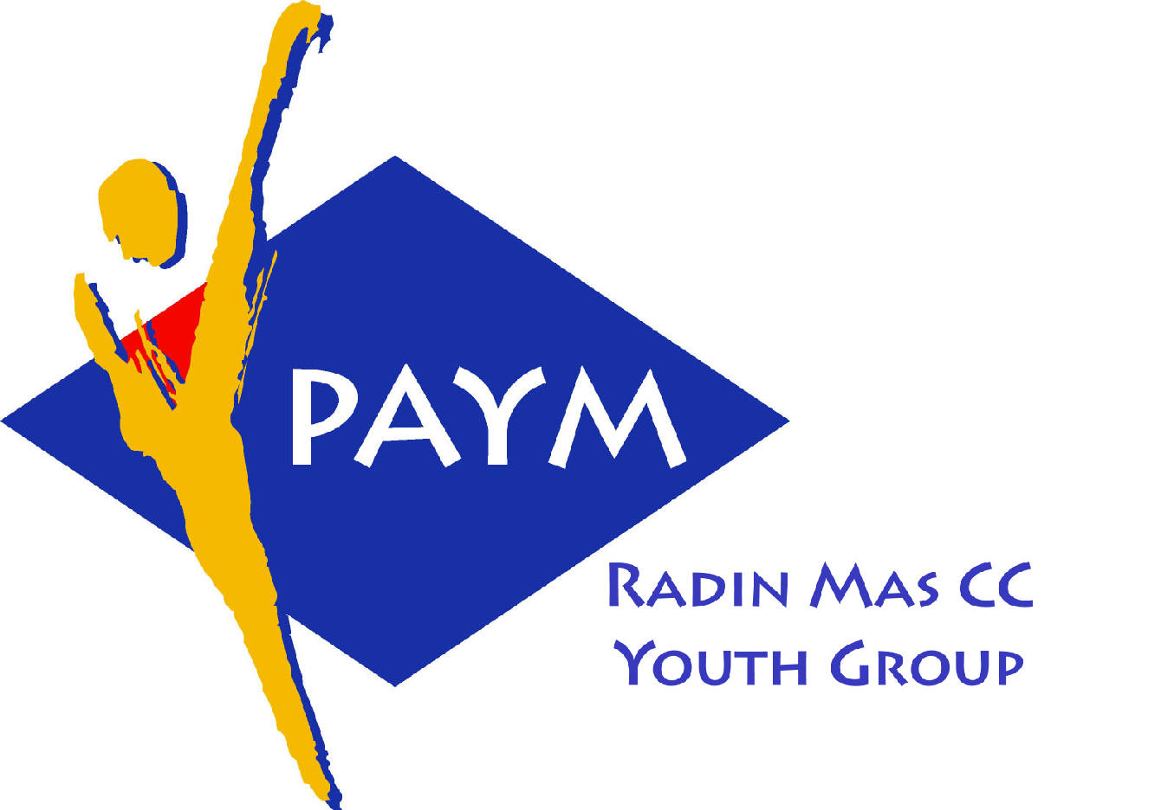
Radin Mas Toastmasters Club

District: 80 Division: D Area: D1 Club No.: 4436
An Activity Group of Radin Mas YEC
1, Telok Blangah Crescent, Singapore 098915
Tel: (65) 6273 5294 Fax: (65) 62730768 E-mail: rm_tm@asiaone.com
http://www.geocities.com/area_d1/Radin_Mas_TMC.htm

Club Mission: To provide a mutually supportive and positive learning environment in which every member has the opportunity to develop communication and leadership skills, which in turn will foster self-confidence and personal growth.
_________________________________________________________________________________________________________

____ Monthly Meeting of Radin Mas Toastmasters Club (2003/2004)
_____________ 2003, Monday, 7.15 pm

Radin Mas Community Club, Level 2, Conference Room

Dear Toastmaster and Visitors,

How would you like to be introduced?

Your Name

Your Club

Date of Meeting _____________

(Please bold, highlite or colour selection)
Your Title: TM / CTM / ATM-B / ATM-S / ATM-G / CL / DTM

Appointment At this Meeting:

SAA / AH counter / Timer / Table Topics Master / Prepared Speech Evaluator /
Language Evaluator / General Evaluator / Guest Speaker

If Prepared Speech Speaker:
Project No:
Title:

(Optional)
Profession

Hobbies:

Family

Others:

