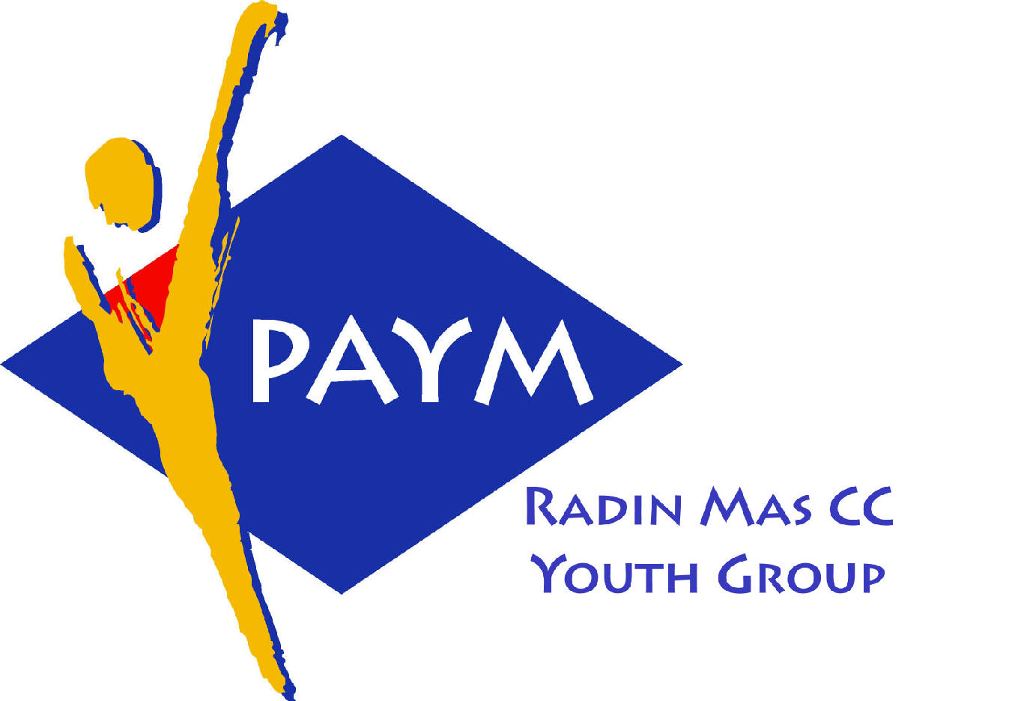
 Radin Mas Toastmasters Club

District: 80 Division: D Area: D1 Club No.: 4436
An Activity Group of Radin Mas YEC
1, Telok Blangah Crescent, Singapore 098915
Tel: (65) 6273 5294 Fax: (65) 62730768
http://www.geocities.com/rm_tmc
Club Mission: To provide a mutually supportive and positive learning environment in which every member has the opportunity to develop communication and leadership skills, this in turn will foster self-confidence and personal growth.
_____________________________________________________________________________________________________
58th Monthly Meeting of Radin Mas Toastmasters Club (2004/2005)
28th February, Monday, 7.00 pm

Radin Mas Community Club, Level 2, Conference Room
5th Exco Committee  President  Vico Liew Yue Wah  97505876  mombasasm@yahoo.com.sg  Vice President Education  Thomas Lai Yew Fai  96800177  laiyf@yahoo.com  Vice President Membership  Tay Yiang Ping ATMB, CL  96221803  yptay@starhub.net.sg  Vice President Publicity  Gabriel Ho  91015751  Gabriel_hch@yahoo.com  Secretary  Chee Kim Loon, CTM  96980338  kimloon@singnet.com.sg  Treasurer  Roger Soh CL  98489205  rogersoh@starhub.net.sg  Sergeant-At-Arms  Russell Cheong  96910869  russellcheong@hotmail.com  Immediate Past President  Roger Soh CL  98489205  rogersoh@starhub.net.sg  Club Advisor:  Susan Wong DTM  Club Coaches:  David Chee, ATM-S, CL  Lynn Desker DTM  Area D1 Governor:  Chee Kim Loon, CTM  Our next meeting  on 28 March (Monday)  We meet every 4th Monday of the month. | 7.00 pm | Reception and fellowship
 | 7.20 pm | SAA Warm Up Session |  | Chee Kim Loon CTM
 | 7.30 pm | Toastmaster of the Evening |  | Sik Ling Ling
 | 7.33 pm | Welcome Address |  | Vico Lew
 | 7.38 pm | Table Topics |  | Tay Yiang Ping ATMB CL
 |  | Timer’s Report |  | Ng Wei Lin
 |  | Vote for 2 Best Table Topic Speakers for Area D1 Contest |  | Chee Kim Loon CTM
 |  | Prepared Speech session Part 1 |  | Sik Ling Ling
 | 8.05 pm | P1: Ice Breaker (4-6 mins) |  | Trixi Lim
 | 8.12 pm | P5: Vocal Variety (5-7 mins) |  | Philip Tan
 | 8.20 pm | P5: Vocal Variety (5-7 mins) |  | Russell Chong
 | 8.28 pm | Break
 |  | Prepared Speech session Part 2 |  | Sik Ling Ling
 | 8.45 pm | P6: Vocal Variety (5-7 mins) – new manual |  | Eric Lau
 | 8:53 pm | P7:Apply Your Skills (5-7 mins |  | Vico Liew
 | 9.01 pm | P8: Add Impact to Your Speech (5-7mins) |  | Thomas Lai
 | 9.09 pm | Timer’s Report |  | Ng Wei Lin
 |  | Vote for Best Speakers and 2 Speakers (P6 and above) for Area D1 Contest |  | Chee Kim Loon CTM
 |  | Evaluation ( 2-3 mins each)
 | 9.11 pm | For Trixi |  | Clara Tan
 | 9.15 pm | For Philip Tan |  | Lily Lim
 | 9.19 pm | For Russell Chong |  | Tay Yiang Ping ATMB CL
 | 9.23 pm | For Eric Lau |  | Sheila Chang CTM
 | 9.27 pm | For Vico Liew |  | Chee Kim Loon CTM
 | 9.31pm | For Thomas Lai |  | Goh Wei Kun ATMS CL
 | 9.35pm | Timer’s Report |  | Ng Wei Lin
 |  | Vote for Best Evaluator
 | 9.37pm | Announcement by VPE |  | Thomas Lai
 | 9.40pm | Closing Awards & Address |  | Vico Liew
 | 9.45 pm | Home Sweet Home
 | Guests  Clara Tan CTM, Club President, CPA TMC  Sheila Chang CTM, VPE, CPA  Lily Lim, VPE Money Master TMC  Goh Wei Kun ATMS, Division Z Governor, Pioneer TMC |  | Announcement:  Area D1 Contests, 7th Mar at HP TMC  Division D Contests, 16th April at Queenstown TMC  This Person Could Help You to be "Power Communicator".... 12th Mar  District 80 Toastmasters Awareness Month – March  Speechcraft 2nd intake: Apr 15, 22 May 6, 13, 23
Last meeting on 13th December 2004
Congratulations to Philip Tan awarded the Best Table Topics Speaker!
Congratulations to Dr. Ho Mian Lian awarded the Best Prepared Speech Speaker!
Congratulations to David Chee awarded the Best Evaluator!

