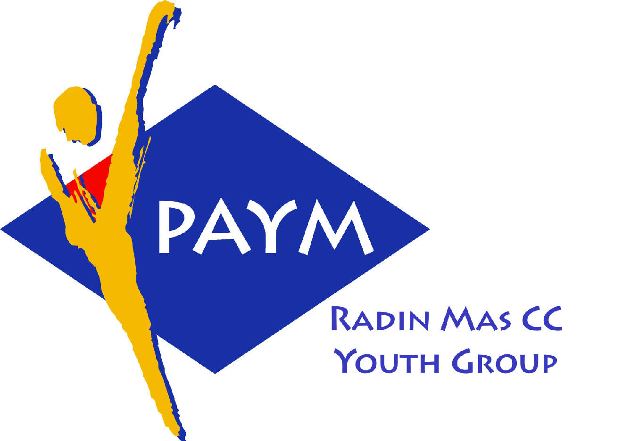
 Radin Mas Toastmasters Club

District: 51 Division: D Area: D1 Club No.: 4436
An Activity Group of Radin Mas YEC
1, Telok Blangah Crescent, Singapore 098915
Tel: (65) 6273 5294 Fax: (65) 62730768
http://www.geocities.com/rm_tmc

Club Mission: To provide a mutually supportive and positive learning environment in which every member has the opportunity to develop communication and leadership skills, which in turn will foster self-confidence and personal growth.
_________________________________________________________________________________________________________

46th Monthly Meeting of Radin Mas Toastmasters Club (2003/2004)
23rd February, Monday, 7.00 pm

Radin Mas Community Club, Level 2, Conference Room

4th Exco Committee  President  Roger Soh CTM  98489205  rogersoh@starhub.net.sg  Vice President Education  Tay Yiang Ping CL  96221803  yptay@starhub.net.sg  Airin Sugiono  97526774  Airin_sugiono@yahoo.com  Vice President Membership  Jackson Chua CL  90026464  tmjacksonchua@yahoo.com.sg  Vice President Publicity  Vico Lew Yue Wah  97505876  mombasasm@yahoo.com.sg  Secretary  Treasurer  Panneer Selvam  98236334  pan17@singnet.com.sg  Sgt-at-arm  Thomas Lai Yew Fai  96800177  laiyf@yahoo.com  Immediate Past President  Vanni Cheong CTM  96174713  wanhoon@singnet.com.sg  Club Advisor:  Susan Wong DTM  Club Coaches:  David Chee, ATM-S, CL  Lynn Desker DTM  Area D1 Governor:  Tay Yiang Ping CL  Our next meeting  on 15 Mar 2004 (Monday)  We meet every 4th Monday of  the month. | 7.00 pm | Reception and fellowship
 | 7.30 pm | SAA Warm Up Session | Ranmalie
 | 7.38 pm | Toastmaster of the Evening | Jackson Chua CL
 | 7.40 pm | Word of the Day | Lynn Desker DTM
 | 7.45 pm | Table Topics Session | David Chee ATM-S, CL
 | 8.05 pm | Timer Report | Thomas Lai
 |  | Vote for Best Speaker
 |  | Special Talk
 | 8.06 pm | Introduction To Toastmasters | Jackson Chua CL
 |  | Prepared Speech session
 | 8.26 pm | P4 Show What You Mean | Thomas Lai
 | 8.34 pm | P6 Work with Words ( 5-7 mins) | Vico Lew
 | 8.42 pm | P7 Apply Your Skill | Kenneth Tan
 | 8.50 pm | Timer Report | Jasmine Tan / Susan Wong
 |  | Break | Ranmalie
 | 9.05 pm | AP5 Speeches By Management – Manage and Motivate (10-12 mins) | Tay Yiang Ping CL
 |  | Evaluation ( 2-3 mins each) | Jackson Chua CL
 | 9.18 pm | For Thomas Lai | Clara Chang DTM
 | 9.22 pm | For Vico Lew | Bruno ATM-B, CL
 | 9.26 pm | For Kenneth Tan | Anthony Leong DTM
 | 9.30 pm | For Tay Yiang Ping | Susan Wong DTM
 | 9.34 pm | Timer Report | Thomas Lai
 | 9.35 pm | Language Evaluation | Lynn Desker DTM
 | 9.45 pm | Ah Counter | Russell Cheong / David Chee
 | 9.46 pm | Induction Ceremony | Michael Rodrigues DTM
 | 10.00pm | Closing Award & Address by Div.D Governor | Michael Rodrigues DTM
External Guest:
Bruno ATMB,CL – Tampines Changkat /New Millennium Advance TMC
Anthony Leong, DTM – New Millennium Advance TMC
Kenneth Tan – NOL TMC
Announcement
Area D1 International Speech & Table Topics Contest
22 Mar 2004 (Monday), SIA Training Centre, 720 Upper Changi Road East

