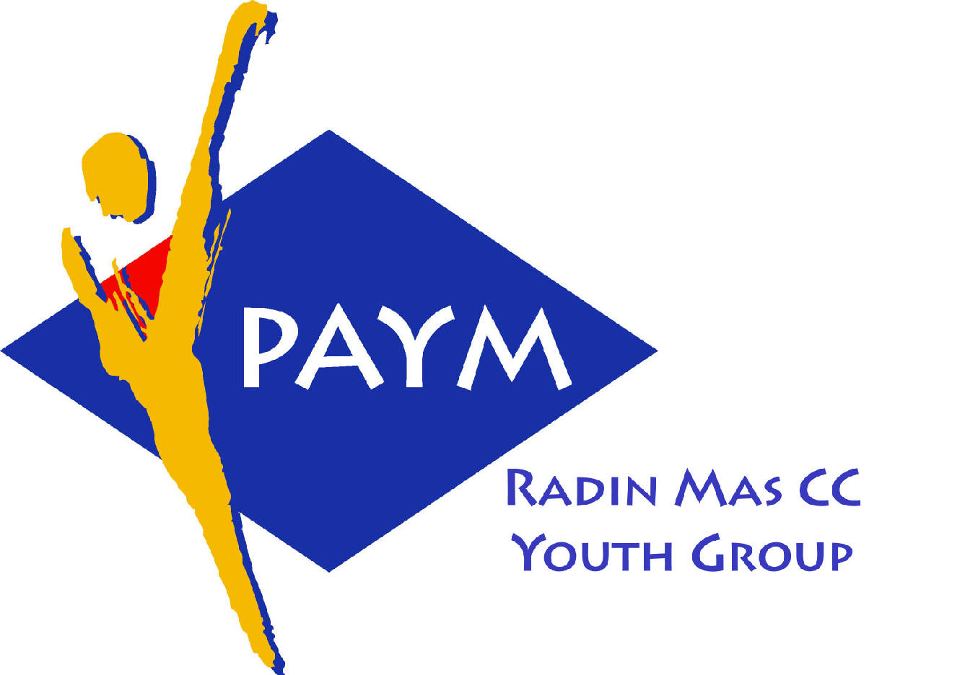
 Radin Mas Toastmasters Club

District: 80 Division: D Area: D1 Club No.: 4436
An Activity Group of Radin Mas YEC
1, Telok Blangah Crescent, Singapore 098915
Tel: (65) 6273 5294 Fax: (65) 62730768
http://www.geocities.com/rm_tmc
Club Mission: To provide a mutually supportive and positive learning environment in which every member has the opportunity to develop communication and leadership skills, this in turn will foster self-confidence and personal growth.
_____________________________________________________________________________________________________
56th Monthly Meeting of Radin Mas Toastmasters Club (2004/2005)
13th December, Monday, 7.00 pm

Radin Mas Community Club, Level 2, Conference Room
5th Exco Committee  President  Vico Liew Yue Wah  97505876  mombasasm@yahoo.com.sg  Vice President Education  Thomas Lai Yew Fai  96800177  laiyf@yahoo.com  Vice President Membership  Tay Yiang Ping ATMB, CL  96221803  yptay@starhub.net.sg  Vice President Publicity  Gabriel Ho  91015751  Gabriel_hch@yahoo.com  Secretary  Chee Kim Loon, CTM  96980338  kimloon@singnet.com.sg  Treasurer  Roger Soh CL  98489205  rogersoh@starhub.net.sg  Sergeant-At-Arms  Russell Cheong  96910869  russellcheong@hotmail.com  Immediate Past President  Roger Soh CL  98489205  rogersoh@starhub.net.sg  Club Advisor:  Susan Wong DTM  Club Coaches:  David Chee, ATM-S, CL  Lynn Desker DTM  Area D1 Governor:  Chee Kim Loon, CTM  Our next meeting  on 24 January (Monday)  We meet every 4th Monday of the month. | 7.00 pm | Reception and fellowship
 | 7.20 pm | SAA Warm Up Session | Philip Tan
 | 7.30 pm | Toastmaster of the Evening | David Chee ATMS CL
 | 7.32 pm | Word of the Day | Patricia Lum DTM
 |  | Prepared Speech session | David Chee ATMS CL
 | 7:34pm | P4: How To Say It (5-7 mins) | Sik Ling Ling
 | 7:42pm | P4: How To Say It (5-7 mins) | Teo Yee Lee
 | 7:50pm | P4: How To Say It (5-7 mins) | Eric Lau
 | 7:58pm | P5: Your Body Speaks (5-7 mins) | Helen Ang
 | 8:06pm | AP2: Resources for Entertainment (5-7mins) | Chee Kim Loon, CTM
 | 8:14pm | AP2: Story Telling – Let’s Get Personal (6-8 mins) | Ho Mian Lian, AG D4 CL
 | 8:23pm | Timer’s Report | Philip Tan
 | 8:24pm | Break | Philip Tan
 |  | Evaluation ( 2-3 mins each)
 | 8:35pm | For Sik Ling Ling | Russell Cheong
 | 8:39pm | For Teo Yee Lee | Thomas Lai
 | 8:43pm | For Eric Lau | Tony Teo CL
 | 8:47pm | For Helen Ang | Roger Soh CL
 | 8:51pm | For Chee Kim Loon | TBA
 | 8:55pm | For Ho Mian Lian | David Chee ATMS CL
 | 8:59pm | Timer’s Report | Philip Tan
 |  | Table Topics
 | 9:00pm | Table Topics | Russell Cheong
 | 9:20pm | Ah Counter Report | TBA
 | 9:22pm | Language Evaluation | Patricia Lum DTM
 | 9.32pm | Closing Award & Address | Thomas Lai
 | 9.35 pm | Home Sweet Home
Guests
Dr Ho Mian Lian AG D4, NBS Staff TMC, CL
Patricia Lum DTM, Ponggol TMC
David Chee ATMS CL, New Millienium Adv. TMC
Bruno Periera ATMS CL, Tampines Changkat TMC
Last Meeting:
Congratulations to Philip Tan awarded the Best Prepared Speech Speaker!
Congratulations to Helen Ang awarded the Best Table Topics Speaker!
Announcement:
Next Club Officers Meeting (COT) on 15th January 2004 Saturday at Ngee Ann Poly.

