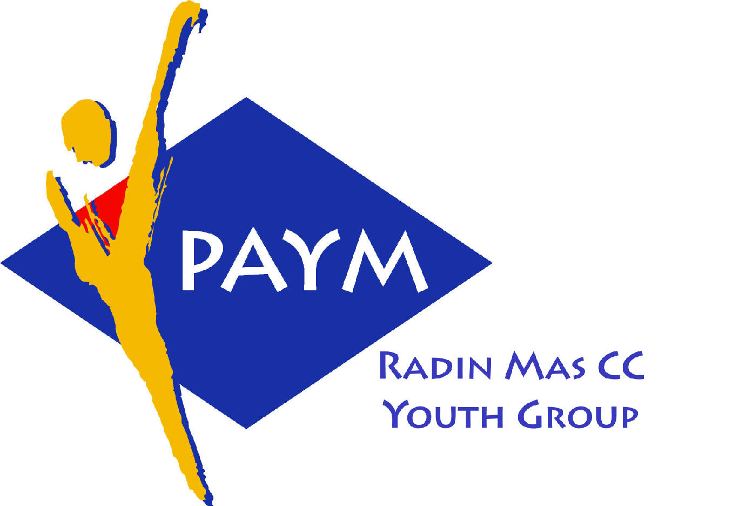
 Radin Mas Toastmasters Club

District: 51 Division: D Area: D1 Club No.: 4436
An Activity Group of Radin Mas YEC
1, Telok Blangah Crescent, Singapore 098915
Tel: (65) 6273 5294 Fax: (65) 62730768
http://www.geocities.com/rm_tmc

Club Mission: To provide a mutually supportive and positive learning environment in which every member has the opportunity to develop communication and leadership skills, which in turn will foster self-confidence and personal growth.
_________________________________________________________________________________________________________

44th Monthly Meeting of Radin Mas Toastmasters Club (2003/2004)
15th December 2003, Monday, 7..00 pm

Radin Mas Community Club, Level 2, Conference Room

4th Exco Committee  President  Roger Soh CTM  98489205  rogersoh@starhub.net.sg  Vice President Education  Tay Yiang Ping CL  96221803  yptay@starhub.net.sg  Airin Sugiono  97526774  Airin_sugiono@yahoo.com  Vice President Membership  Jackson Chua CL  90026464  tmjacksonchua@yahoo.com.sg  Vice President Publicity  Vico Lew Yue Wah  97505876  mombasasm@yahoo.com.sg  Secretary  Treasurer  Panneer Selvam  98236334  pan17@singnet.com.sg  Sgt-at-arm  Thomas Lai Yew Fai  96800177  laiyf@yahoo.com  Immediate Past President  Vanni Cheong CTM  96174713  wanhoon@singnet.com.sg  Club Advisor:  Susan Wong DTM  Club Coaches:  David Chee, ATM-S  Lynn Desker DTM  Area D1 Governor:  Tay Yiang Ping CL  Our next meeting  on 19 Jan 2004 (Monday)  and  OPEN HOUSE  On 21 Dec 2003 (Sunday)  We meet every 3rd Monday of  the month. | 7.00 pm | Reception and fellowship
 | 7.30 pm | SAA Warm Up Session
 | 7.38 pm | Toastmaster of the Evening |  | Vanni Cheong ATMB
 | 7.42 pm | Word of the Day
 | 7.43 pm | Table Topics Session |  | Susan Wong DTM
 | 8.03 pm | Timer Report
 |  | Vote for Best Speaker
 |  | Prepared Speech session
 | 8.05 pm | P2 Speak with Sincerity ( 5-7 mins) |  | Ranmalie
 | 8.13 pm | P3 Organise your Speech (5-7 mins) |  | Thomas Lai
 | 8.21 pm | P6 Work with Words (5-7 mins) |  | Vico Lew
 | 8.29 pm | AP (15-20 mins) |  | Sam Choo CTM
 |  | Timer Report
 |  | Vote for Best Speaker
 | 9.00 pm | Break
 |  | Evaluation ( 2-3 mins each)
 | 9.15 pm | For Ranmalie |  | Wilson Liu CTM
 | 9.21 pm | For Thomas Lai |  | David Tan CTM
 | 9.25 pm | For Vico Lew
 | 9.29pm | For Sam Choo |  | Anthony Leong DTM
 | 9.33 pm | Timer Report
 |  | Vote for Best Speaker
 | 9.34 pm | Language Evaluation |  | Bruno Pereira ATMB
 | 9.44pm | General Evaluator |  | Tan Choong Song DTM
 | 9.54 pm | Ah Counter
 | 9.55 pm | Closing Award and Home Sweet Home” |  | Roger
 | ** External Guest:

