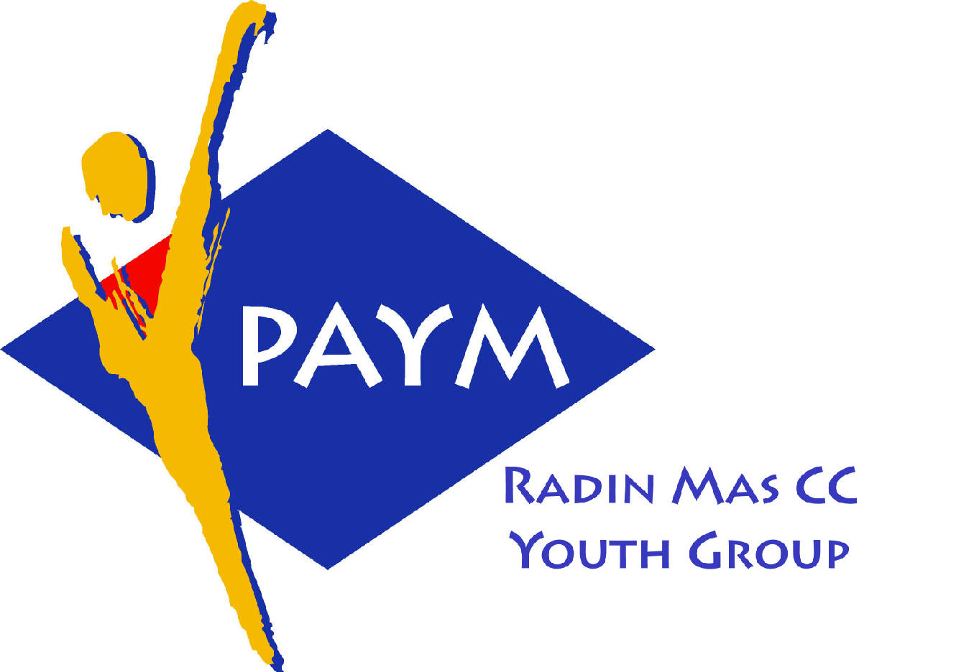
 Radin Mas Toastmasters Club

District: 51 Division: D Area: D1 Club No.: 4436
An Activity Group of Radin Mas YEC
1, Telok Blangah Crescent, Singapore 098915
Tel: (65) 6273 5294 Fax: (65) 62730768
http://www.geocities.com/rm_tmc
Club Mission: To provide a mutually supportive and positive learning environment in which every member has the opportunity to develop communication and leadership skills, this in turn will foster self-confidence and personal growth.
_____________________________________________________________________________________________________
52nd Monthly Meeting of Radin Mas Toastmasters Club (2004/2005)
23th August, Monday, 7.00 pm

Radin Mas Community Club, Level 2, Conference Room
5th Exco Committee  President  Vico Liew Yue Wah  97505876  mombasasm@yahoo.com.sg  Vice President Education  Thomas Lai Yew Fai  96800177  laiyf@yahoo.com  Vice President Membership  Tay Yiang Ping ATMB, CL  96221803  yptay@starhub.net.sg  Vice President Publicity  Gabriel Ho  91015751  Gabriel_hch@yahoo.com  Secretary  Chee Kim Loon, CTM  96980338  kimloon@singnet.com.sg  Treasurer  Roger Soh CL  98489205  rogersoh@starhub.net.sg  Sgt-at-arm  Russell Cheong  96910869  russellcheong@hotmail.com  Immediate Past President  Roger Soh CL  98489205  rogersoh@starhub.net.sg  Club Advisor:  Susan Wong DTM  Club Coaches:  David Chee, ATM-S, CL  Lynn Desker DTM  Area D1 Governor:  Chee Kim Loon, CTM  Our next meeting  on 27 September 2004 (Monday)  We meet every 4th Monday of the month. | 7.00 pm | Reception and fellowship
 | 7.20 pm | SAA Warm Up Session | Russell Cheong
 | 7.28 pm | Toastmaster of the Evening | David Goh ATMS CL
 | 7.30 pm | Word of the Day | Peter Soh ATM-S CL
 | 7:35 pm | Club President Opening Address | Vico Liew
 | 7:38pm | Table Topics | Russell Cheong
 |  | Prepared Speech session
 | 8:03pm | Humorously Speaking AP1 (5-7 mins) | Tay Yiang Ping ATMB, CL
 | 8:11pm | Specialty Speech AP1: Speak Off The Cuff (5-7 mins) | Bruno Pereira ATMS, CL
 | 8:19pm | Humorous Project Speech (5-7 mins) | David Chee ATMS, CL
 | 8:27pm | Timer Report | Thomas Lai
 |  | Break
 |  | Evaluation ( 2-3 mins each)
 | 8:48pm | For Yiang Ping | Thomas Lai
 | 8:52pm | For Bruno | Ng Mui Choo CTM
 | 9.00pm | For David Chee | Gabriel
 | 9.08pm | Timer Report | Thomas Lai
 | 9.09pm | Language Evaluation | Peter Soh ATMS CL
 | 9:20pm | General Evaluation / How Toastmasters Can Help You | Lynn Desker
 | 9.30pm | Ah Counter | Daniel Goh CL
 | 9.32pm | Closing Award & Address | Vico Liew
 | 9.35 pm | Home Sweet Home
External Guest:
Bruno Pereira ATMS, CL, Tampines Changkat, New Millennium Adv TMC
David Chee ATMS CL, New Millennium Adv
Peter Soh ATMS, CL Area S2 Governor, Thomson TMC
David Goh ATM-S, CL, Sky Media TMC
Ng Mui Choo CTM, Skymedia TMC
Daniel Goh CL, Div U Asst. Gov. Marketing, Tampines Changkat TMC

Announcement:
Area D1 Humorous and Evaluation Speech Contest 22 Sep(Wed)
Division D Humorous and Evaluation Speech Contest 16 Oct(Sat)

