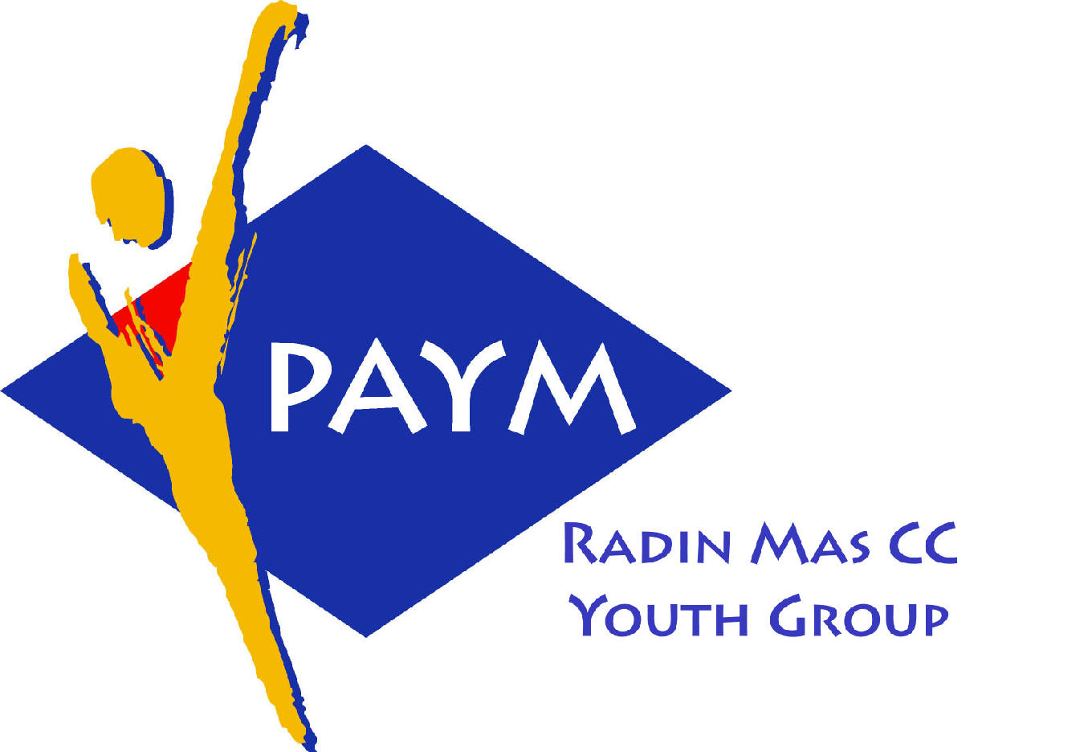
 Radin Mas Toastmasters Club

District: 51 Division: D Area: D1 Club No.: 4436
An Activity Group of Radin Mas YEC
1, Telok Blangah Crescent, Singapore 098915
Tel: (65) 6273 5294 Fax: (65) 62730768
http://www.geocities.com/rm_tmc
Club Mission: To provide a mutually supportive and positive learning environment in which every member has the opportunity to develop communication and leadership skills, which in turn will foster self-confidence and personal growth.
_____________________________________________________________________________________________________
48th Monthly Meeting of Radin Mas Toastmasters Club (2003/2004)
26th April, Monday, 7.00 pm

Radin Mas Community Club, Level 2, Conference Room
4th Exco Committee  President  Roger Soh CTM  98489205  rogersoh@starhub.net.sg  Vice President Education  Tay Yiang Ping CL  96221803  yptay@starhub.net.sg  Airin Sugiono  97526774  Airin_sugiono@yahoo.com  Vice President Membership  Jackson Chua CL  90026464  tmjacksonchua@yahoo.com.sg  Vice President Publicity  Vico Lew Yue Wah  97505876  mombasasm@yahoo.com.sg  Secretary  Treasurer  Panneer Selvam  98236334  pan17@singnet.com.sg  Sgt-at-arm  Thomas Lai Yew Fai  96800177  laiyf@yahoo.com  Immediate Past President  Vanni Cheong CTM  96174713  wanhoon@singnet.com.sg  Club Advisor:  Susan Wong DTM  Club Coaches:  David Chee, ATM-S, CL  Lynn Desker DTM  Area D1 Governor:  Tay Yiang Ping CL  Our next meeting  on 24 May 2004 (Monday)  We meet every 4th Monday of the month. | 7.00 pm | Reception and fellowship
 | 7.20 pm | SAA Warm Up Session | Susan Wong DTM
 | 7.28 pm | Toastmaster of the Evening | Clara Chang DTM
 | 7.30 pm | Word of the Day | Theresa Sng ATM-B
 | 7.35 pm | Table Topics Session | Linda Neo
 | 8.00 pm | Timer Report | Jasmine Tan
 |  | Vote for Best Speaker
 |  | Prepared Speech session | David Chee ATM-S, CL
 | 8.01 pm | P2 Organize Your Speech (5-7 mins) | Gabriel Ho
 | 8.09 pm | P2 Organize Your Speech (5-7 mins) | Russell Cheong
 | 8.17 pm | AP 2 – Speech By Management (8-10 mins)  The Technical Speech | Tay Yiang Ping
 | 8.27 pm | AP 1 – Interpretive Reading – Read A Story (8-10 mins) | Jackson Chua ATM-B
 | 8.37 pm | Timer Report | Jasmine Tan
 |  | Break | Susan Wong DTM
 |  | Evaluation ( 2-3 mins each) | Clara Chang DTM
 | 9.00 pm | For Gabriel Ho | Michael Seet
 | 9.04 pm | For Russell Cheong | Stanley Goh CL
 | 9.12 pm | For Tay Yiang Ping | Boey Yut Mei ATM-B, CL
 | 9.16 pm | For Jackson Chua | Bruno ATM-B, CL
 | 9.20 pm | Timer Report | Jasmine Tan
 | 9.21 pm | Language Evaluation | Theresa Sng ATM-B
 | 9.31 pm | General Evaluation | Anthony Leong DTM
 | 9.41 pm | Ah Counter | Yip Yew Seng
 | 9.42 pm | Closing Award & Address | Susan Wong DTM
 | 9.45 pm | Home Sweet Home
External Guest:
Stanley Goh, CL: Thomson TMC
Bruno ATM-B, CL: New Millenium Adv TMC and Tampines Changkat TMC
Anthony Leong DTM : New Millenium Adv TMC
Theresa Sng ATM-B – New Millenium TMC
Boey Yut Mei ATM-B CL – Area B3 Governor, The Cultural Society/ Breakthrough/ Bukit Merah TMC
Linda Neo and Michael Seet – Raffles Town TMC
Yip Yew Seng – Chua Chu Kang TMC
Last Meeting Awards
Best Project Speaker: Russell Cheong
Best Table Topics – Ranmilie
Best Evaluator – Chan Boon Hwee
Announcement:
11th Annual Convention in Penang from 27-30 May
Welcome our new members: DTM Lynn Desker and DTM Susan Wong

