What Others have to  Say About Toastmasters  “If you want your dreams to come true, you must have confidence in yourself and your abilities. A Toastmasters Club can give you that confidence. Make your dreams a reality. Join a Toastmasters  Club.”  - Lee Brown, Top US Motivational Speaker, Author of “Love Your Dreams”, and “It’s Not Over Until You Win!”  "I have never met anyone who did not think Toastmasters was super valuable to their career. We gain self-esteem, self-confidence, assertiveness. This makes us better sales people, better managers, better leaders…."  - Harvey Mackay, Author of the  bestseller "How To Swim With The Sharks Without Being Eaten Alive",  and other top-selling books.  The Club's Mission  The mission of a Toastmasters Club is to provide a mutually supportive and positive learning environment in which every member has the opportunity to develop communication and leadership skills, which in turn foster self-confidence and personal growth
  Web Resources
  For avid net surfers, here are some
  useful websites :
  1. District 80 Online
  www.district80.org
  2. Toastmasters International
  www.toastmasters.org
  If you have any further enquiries about
  our Club or any aspects of the
  Toastmasters program, please feel free
  to approach us, and we
  will do our best to help you.
  You can contact us
  through phone or email :
  Sienna V. Lazaro, CC CL
  94792018
  svlazaro@yahoo.com
  Maggie Soh CC CL
  9819 3139
  msoh@tycoint.com
  Empower people to achieve their
  full potential and realize their dreams
  Nee Soon South Toastmasters Club
  www.geocities.com/nss_tmc
  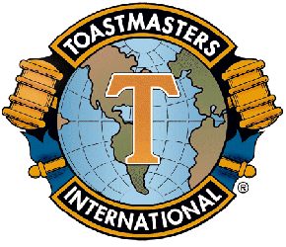
  Afraid to Speak in Public?
  Would You Like To:
  Develop Your Potential?
  Speak With Confidence And Ease?
  Learn New Leadership Skills?
  Communicate More Effectively
  In Your Business And Personal Life?
  How Can We Help You?
  " MAKE A DIFFERENCE
  & PARTICIPATE"

