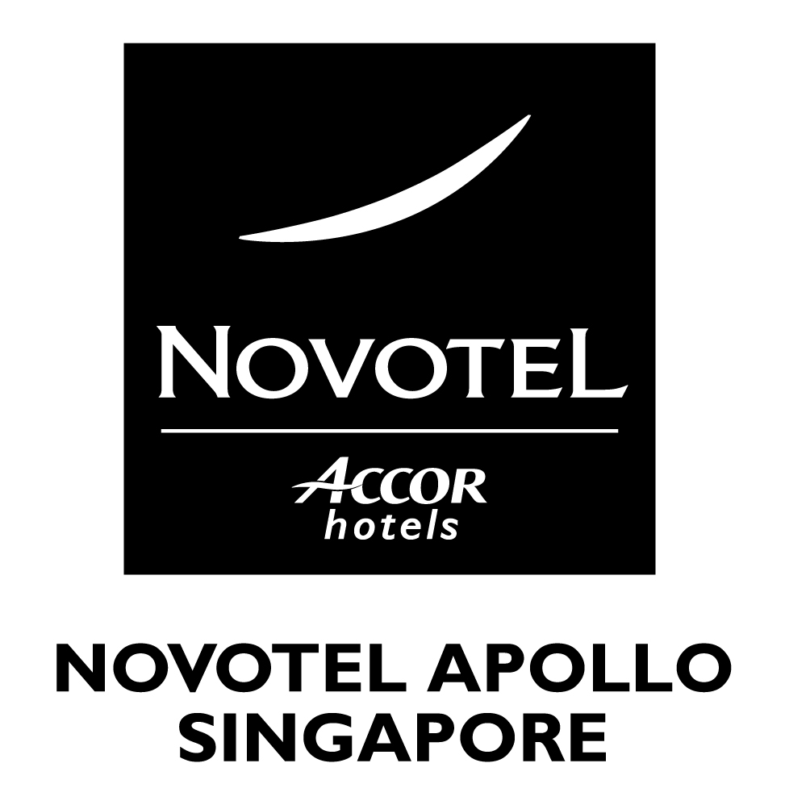
Reservation Form

Toastmasters International (10 July 2004)

To: Novotel Apollo Singapore Name of company:
Sharon Lim (Sales & Marketing) Name of Booker:
Tel: 65 6739 6426 Fax: 65 67327025 Tel: Fax:
E-mail: sales@novotelapollo.com E-mail:

Room Category | Special Rates  (With breakfast)
Room Category | Single / Twin
Superior Room | S$120 nett / $130 nett

Name of guest: ____________________ Toastmasters District______________
Address: _______________________________________________________________
Tel: ________________ Fax: ________________ E-mail: ________________
Type of Room: ____________________ *Single / Twin (Please delete accordingly)
Room Rate: __________________
Date/Time of Arrival: ______________________ Flight No: ____________________
Date/Time of Departure: ____________________ Flight No: ____________________
- Please tick if you require airport transfer (at a designated timing)
Please proceed to the Hotel Reservation Counter at the Arrival Hall for the shuttle to hotel
Terminal One - Located directly opposite Belt/Gate 16 and Belt/Gate 23
Terminal Two - Located directly opposite Belt/Gate 31 and Belt/Gate 38

Payment:
Personal Account - Credit Card No: _________________________ Expiry Date: ________

- Reservations will be held till 1800 hours if no flight details are given or at maximum, two hours after your confirmed arrival time.

- Please be advised that a one night's room charge will be levied for no show or cancellation made after 1800 hours on day of arrival.

Hotel use

Confirmed by: _________________ Date: _____________
Confirmation No: _______________

