TOASTMASTERS INTERNATIONAL DISTRICT 80

Serving Clubs in Hong Kong, Macau, Singapore, and Thailand

LANGUAGE EVALUATION WORKSHOP
❖ 23 OCTOBER 2004 
❖ YMCA ORCHARD, SINGAPORE 
1 Orchard Road, Singapore 238824
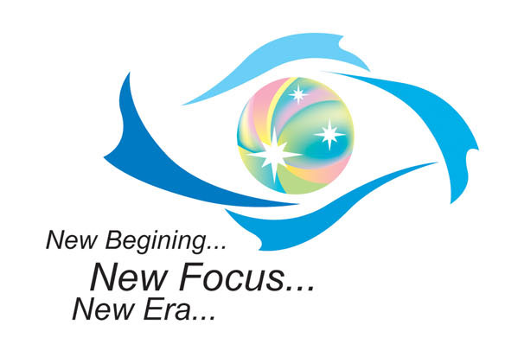  Do It Now! |  | 

Brought to you by  The D80 E & T Task Force  OrganiSing Committee & Facilitators  Lieutenant Governor Education & Training  Dr. Khong Chooi Peng DTM  ascpkhong@ntu.edu.sg  6790-5049  Division U Governor  Jackson Chua ATM-S CL  tmjacksonchua@yahoo.com.sg  9002-6464  Nanyang BrassTacks President  Nimmi Agnes Jayathurai CL  asnimmi@ntu.edu.sg  6790-5783  PRESENTERs:  Style & Language:  Area D5 Governor  Albert Lim, ATM-S, CL  lim_16@pacific.net.sg  HP: 9387-2244  Delivery Techniques:  John Tan Yew How, ATM-B  lifematters@pacific.net.sg  HP: 9620-1250  Grammar & TM-Related Items:  Area B4 Governor  Tan May Yan CL  Tan.May.Yan@singhealth.com.sg  HP: 9829-8773  Kan Kin Fung, DTM  kankf@post.com  6552-6990  Ang Swee Thian, ATM-S  Area S5 Governor  speakfolio@yahoo.com.sg  HP: 9640-7826 | PROGRAMME
 | 1:30 pm | REGISTRATION & FELLOWSHIP
 | 2:00 pm | TMD Welcomes All
 | 2.05pm | Opening Address  LGET Dr. Khong Chooi Peng DTM
 | 2.15-pm | “Singaporean Pronunciation: Can the world unDerstand us?” Talk and Q & A by  Prof Low Ee Ling, National Institute of Education, Singapore
 | 3.15 pm | TEA BREAK
 | 3.25 pm | LANGUAGE EVALUATION WORKSHOP Part 1  - Strategic Methods & Approaches to Language Evaluation!  - Valuable Guides on Style, Delivery, & Grammar  - Video Screening with Personalised Worksheets  - Hands-On Evaluation of Speakers
 | 4.30pm | LANGUAGE EVALUATION WORKSHOP Part 2  - Facilitator-led Step by Step Method to LE  - Personalised Worksheets for Lively Discussions  - Summary of New LE Techniques  - Mastering LE!
 | 5.15pm | Final Wrap-up & Closing Address  LGET Dr. Khong Chooi Peng DTM
 | 5.40pm | Home Sweet Home … Enlightened, Entertained, Energised!  The Force is with you!

MARK 16 February in your CALENDAR!
Aiming to ace Manual Project Speeches with ease, style, & impact?
The E &T Task Force brings you another new-concept Workshop tailored especially for you! Watch out for details!

