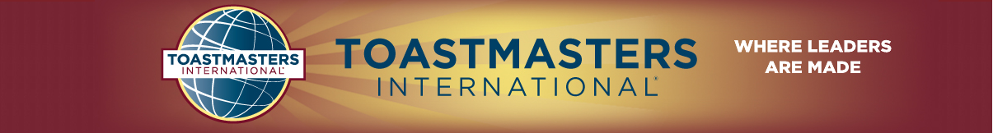
District 80 Singapore
2nd District 80 Council Meeting 2014-2015
22 May 2015 Friday 7.30pm to 9 p.m.

Credential or Proxy Certificate District Council Meeting – 22nd May 2015

At the District Council Meeting, each Club President and Vice President of Education in attendance is entitled to one vote. However, if either or both officers cannot attend, they may designate, in writing, any other active member of their club to act as proxy or proxies for their club. (Use form below). In compliance with Article X, Paragraph (d) of the District Administrative Bylaws, no other proxies are valid at the meeting.

In the event one of the club officers does not attend the meeting and has not designated, in writing, an active member of the club to act as his or her proxy, the officer or proxy holder in attendance is deemed to hold the proxy of the other, and may therefore cast two votes at the meeting. This will ensure each club has two votes.

In addition, each district officer, including area governors, in attendance is entitled to one vote. Only district executive committee members carrying proxy certificates from their club are allowed three votes. All other members are limited to a maximum of two votes each.

Date 22nd May 2015 Certificate No ___________
To be submitted to Credentials Desk in exchange for ballot(s)

Name of Club: __________________________________________________________Toastmasters Club.

Club No: _______________________________________________________________________________

Name: ________________________________________________________________________________

Officer Position: *Club President/Vice President of Education

*Delete as appropriate
IF YOU ARE UNABLE TO ATTEND
Club President & Vice President of Education only

Indicate particulars of your duly authorised proxy below (your proxy must be an active member of your club.)

Proxy’s Name :________________________________________________________________________

Club President/Vice President’s Signature: ______________________________Date:_________________

