Report from 2008 Singapore Annual Convention Chair
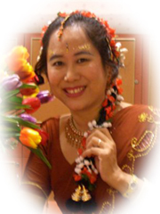 |  | 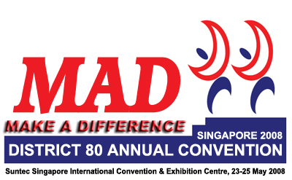
Tay Yiang Ping ACS AL

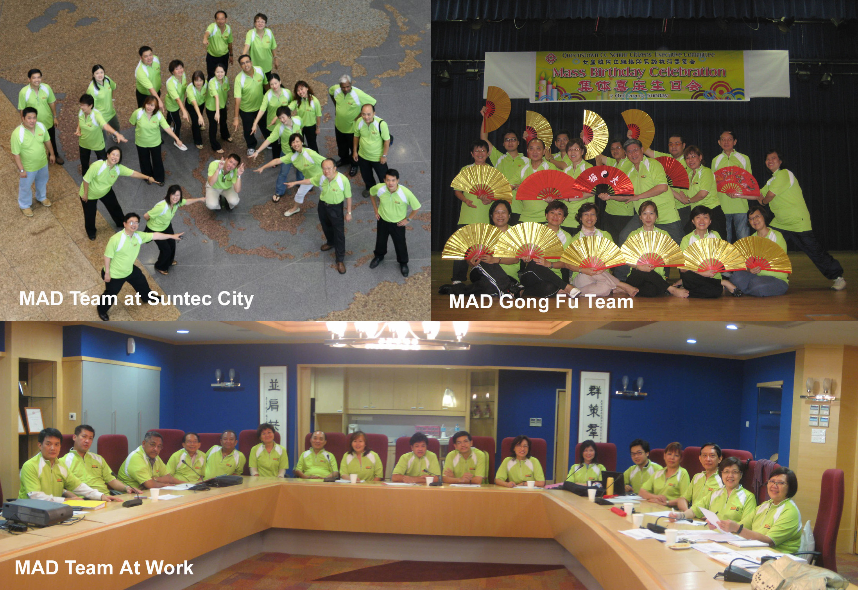
Special Thanks to our MAD Team!

Date/Day: | 23rd – 25th May 2008 / Friday to Sunday
Theme: | MAD - Make A Difference
Venue: | Suntec Singapore International Convention & Exhibition Centre
Website: | www.district80.org/2008annualconvention
Price |  | Individual | 5 in a group
Now until 20 Nov 2007 |  | S$308 | S$298
From 21 Nov 2007 |  | S$338 | S$328
To register:
  Payment Method: Crossed Cheque made payable to “Tay Yiang Ping”
  Post to: 15 Countryside Road Singapore 789781
Contacts: | Organising Chair : Tay Yiang Ping, yptay@starhub.net.sg  Co-Chair: Michael Rodrigues, mikejrod@singnet.com.sg  Treasurer: Monica Goh, z1737@singnet.com.sg
Sponsors: | Cash + Sponsor-In-Kind received approx. S$24,000, out of S$34,000
Tickets sold: | 350 Tickets Sold, out of 500 Target, Total capacity 594 for Theatre.  Dateline for 500 Target is 31 Jan 2008.  We may consider Events’ Tickets for Dinners & Contests once the target met.
Budget: | As per District 80 Treasurer Account Report

Proposed Programme:
23 May 2008, Friday
Morning | District 80 Exco & Council meeting
Afternoon  (Tea Break) | Breakout Sessions | 1.  2. | English Workshops  Mandarin Workshops
Evening | Welcome Dinner, Theme - “MAD”
24 May 2008, Saturday
Morning  (Tea Break) | Opening Ceremony | 1.  2.  3. | Flags Parade  Guest-of-Honour Speech  – Mr. Abdullah Tarmugi, Speaker of the Singapore Parliament  Opening Keynote – Ed Hearn, 2006 World Champion Public Speaking
Lunch
Afternoon  (Tea Break) | Breakout Sessions  Will include Online selection of Breakout Sessions when time near | 1.  2.  3.  4. | English Breakout Sessions - 3 Concurrent Workshops  Track A - Communication & Personal Growth  Track B - Skills Buildings  Track C - Club Succession and Leadership  Mandarin International Speech Contest  Mandarin Table Topics Contest  Tamil Workshop/Contest
 | General Session |  | 2006 World Champion Public Speaker
Evening | Gala Dinner / Installation | 1.  2.  3.  4. | Gala Keynote Speech – Anne Barab DAM, The Resilience Expert  Installation of District Officers  Appreciation Awards  Entertainment / Performance
25 May 2008, Sunday
Morning  Tea Break) | Contests / Closing Ceremony | 1.  2.  3 | English International Speech Contest  English Table Topics Contest  Closing
Farewell Lunch
Afternoon | Incoming District Officers Training

Confirmed Convention Workshops Speakers:
Ed Hearn | 2006 World Convention of Public Speaking – Opening Keynote
Anne Barab DTM | Acredited Speaker, The Resilience Expert – Gala Keynote
Dr Andrew Goh | One of Asean´s Top Motivational and Management Trainers
Jill Lowe | Asia Premier Leading Image Consultant since 1985
Lynn Desker DTM | Leadership development

Pre-Convention Workshops
Objective: | To raise fund and awareness of our MAD Convention  - special price to Convention Delegates.
Speaker: | Dr. A. Arulnathan, DTM, Past District 51 Governor
Date: | 12 January 2008
Venue: | Queenstown CC Auditorium (270 Seats)
Titles: | Power of the Subconscious Mind 1.30pm – 5pm  Memory Techniques 6pm – 9.30pm
Contact: | John Tan, lifematters@pacific.net.sg

