Report from 2008 Singapore Annual Convention Chair
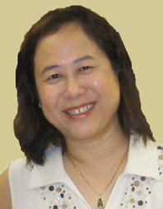 |  | 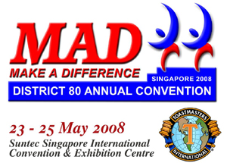
Tay Yiang Ping DTM
Date/Day: | 23 – 25 May 2008 / Friday to Sunday
Theme: | MAD - Make A Difference
Venue: | Suntec Singapore International Convention & Exhibition Centre
Website: | www.district80.org/2008annualconvention
3 Early Bird Lucky Draw Winners, each receive:- 2 Tickets to visit the World's First Wildlife Park, Singapore Night Safari in May 2008 |  | Single | 5 in a group / person | Ticket Paid / total
Register before 20 May 2007 - Early |  | $268 | $268 | 438/  441
21 May - 31 Aug 2007: For HK & Singapore 2007 Delegates only |  | $288 | $278 | 438/  441
21 May - 20 Nov 2007 |  | $308 | $298 | 438/  441
From 21 Nov 2007 |  | $338 | $328 | 438/  441
"Event Only Ticket"
A. Latin Gala Dinner / Installation Night /Gala Keynote Speech by Anne Barab DTM, 24 May 08, Saturday, Ballroom 1 & 2, 7pm |  | $98 | $90 | 8 / 9
B. International Speech and Table Topics Contests (with Lunch)  25 May 08, Sunday, Theatre, 8.30am |  | $80 | $80 | 45 /46
AB. Latino Gala Dinner + International Speech and Table Topics Contests |  | $160 | $160 | 10 / 11
C. 华语专题讲座 23 May 08, Friday, Room 202, 2-5pm |  | $48 | $40 | 9 / 9
D. 华语讲演比赛 24 May 08, Saturday, Room 202, 2.30-5.45pm |  | $48 | $40 | 43 / 43
CD. 华语专题讲座 / 华语讲演比赛 |  | $80 | $80 | 0

Pre-Convention Workshops (It was a full house event!)
Speaker: | Dr. A. Arulnathan, DTM, Past District 51 Governor
Date: | 12 January 2008
Venue: | Queenstown CC Auditorium (270 Seats)
Titles: | Power of the Subconscious Mind 1.30pm – 5pm  Memory Techniques 6pm – 9.30pm
Essay Competition :
How Joining The Toastmasters Movement make a difference in your life?
Prizes are given to Top 5 Essays and 10 Commendation Entries

Budget Update
The main funding for the event are from the sale of full event and single event tickets, sponsorship and magazine advertisements as well as net income from the pre-convention workshops. Our main sponsors are from Cristofori Music School, Design Format, Golam Hossain, Imaginit Technologies, Yokogawa and Cambridge University Press.

The costs and expenses for the event have been closely and carefully monitored to ensure that they are kept within budget while not compromising on the quality. With aggressive promotion, the ticket sale has hit above the budgeted 400 pax mark. Net income is expected to be slightly above break even.

Programme:
23 May 2008, Friday
Morning | District 80 Exco & Council meeting
Afternoon  (Tea Break) | Breakout Sessions | 1.  2. | English Workshops – Anne Barab DTM  Mandarin Workshops - 李秉萱DTM / 孙策
Evening | Welcome Dinner, Theme - “MAD”
24 May 2008, Saturday
Morning  (Tea Break) | Opening Ceremony | 1.  2.  3. | Flags Parade  Guest-of-Honour Speech  – Mr. Abdullah Tarmugi, Speaker of the Singapore Parliament  Opening Keynote  – Ed Hearn, 2006 World Champion of Public Speaking
Lunch
 | General Session |  | – Ed Hearn, 2006 World Champion of Public Speaking
Afternoon  (Tea Break) | Breakout Sessions  Online selection of Breakout Sessions | 1.  2.  3. | English Breakout Sessions - 3 Concurrent Workshops  Mandarin International Speech & Table Topics Contests  Tamil Workshop/Contest  - Speaker, G B Srithar
  Educational Tracks |  | Speakers
  Track A | Communication | Kelvin Ong DTM / Alison Lester / Gerald Green DTM
  Track B | Personal Growth | Dr. Andrew Goh / Jill Lowe
  Track C | Leadership | Lynn Desker DTM / Talis Wong DTM
  Track D | Club Success | Damrong Watanaluck ATMS
Evening | Gala Dinner / Installation | 1.  2.  3. | Gala Keynote Speech – Anne Barab DTM  Installation of District Officers  Entertainment / Performance
25 May 2008, Sunday
Morning  (Tea Break) | Contests / Closing Ceremony | 1.  2. | English International Speech & Table Topics Contests  Closing Ceremony
Farewell Lunch
Afternoon | Incoming District Exco Meeting and District Officers Training

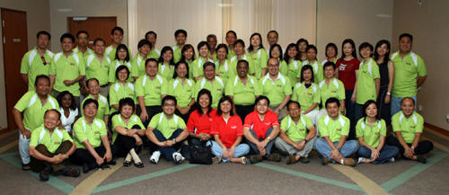
More than 50 members turned up at the MAD Team-Buidling Day on 23 March 2008!

